Pen testing is simulating a test to check what damage can occur to

1) Confidentiality

2) Integrity

3) Availability

Ethical Hacking is just knowledge and Pen testing is a field based on it.

Approaches of PT:

Black box- a condition in which we don't have any information about the target

grey box- a condition in which we have some information about the target

white box- a condition in which we have all the required information.

Types-

Network- network PTs, host PTs, routers, hubs

Web- webserver, database, API , applets, plugins

Client Side- browser, email, content creation apps, media players

Social Engg.- playing with minds and emotions of the people related to our target

Wireless - cables of wifi and other wireless communication.

Physical - breaking physical barriers like infrastructure

Phases:

Pre-Attack - planning and structuring for attack phase

Attack - technical stuff

Post-Attack - meetings and results for explaining our Pts

Technical Hacking- breaking the security technically

Non- Tech Hacking- breaking the people related to our targets using social engineering.

Methodologies- A step by step procedure of doing pen testing -

ex- OSSTMM, OWASP Testing guides

Standards - Required Test Specifications(recommendations)

ex- NIST SP 800-115, PTES

Compliance- Following a rule or an order

ex- PCI DS(payment cards), HIPAA(healthcare), GDPR, NY DFS.. many more

PROCESS OF SECURITY TESTING:

1)Information Gathering

2)Vulnerability Analysis

3)Exploitation

4)Post- Exploitation

5)House Cleaning

Vulnerability- weakness/bug/glitch flaw in target

Exploit - piece of code which we use to abuse that vulnerability

Payload - is like the ammo(bullet) if exploit is a gun

Scope - a list of devices which we are allowed to hack

Asset- anything valuable to the organisation

Risk - It is the probability of the vulnerability being exploited by the         payload

Common Vulnerability Exposure(CVE)- a CVE no. is tagged to a new vulnerability when discovered.( site- CVE DETAILS.)

(lec-2 was just installation and setup)

**FILE SYSTEM**

1) **bin** - contains basic executable programs

2) **boot**- contains files required to start the system

3) **dev**- contains information of devices

4) **etc** - contains configuration files

5) **home** - contains all the user folders except the root folder

6) **root**- contains files of the root user, which can't be accessed by a normal user

7) **lib**- contains all shared libraries which can be used by all programs

8) **media**- contains info about external (removable) devices

9) **mnt** (mounting devices)- any pen drive or other device can be read here.

* 1. **opt**(optional)- some addons of applications and software goes here
  2. **proc**- contains information about all the processes in the system along with their process ids
  3. **sbin**- contains the system binaries which are not accessible by normal users
  4. **srv**- it contains all the services information
  5. **sys**- for other system files
  6. **tmp**- contains the temporary files which are accessible by all the users
  7. **usr**- contains all files(static data) which are accessible to all the users
  8. **var**- contains logs and other variable/dynamic data(i.e. not static) which system can modify if needed

![KALI LINUX COMMANDS

$ (dollar) in terminal represents that you are a non-root user
# (hash) in terminal represents that you are the root user
~ (tilde)  in terminal represents that you are currently at the home directory of the user, i.e. the root directory of that user.
/ (slash) in terminal represents that you are in the highest directory which contains all other directories
Linux is case sensitive
Up/Down arrow keys can be used to see the commands which you used earlier and after.
Ctrl + A moves you to the beginning of any line
Ctrl + E moves you to the end of any line
Ctrl + S freezes the terminal and now you can't write more commands on it
Ctrl + C and Ctrl + Z are used to stop any command that is currently working. Ctrl + C will stop and terminate the command, while Ctrl + Z will simply 
pause the command
Terminal's text size can be increased using Ctrl++ and decreased using Ctrl-- .
Multiple commands can be run in one command by separating them with a semicolon(;).

 pwd- print working directory

 cd- change directory

 cd .. - to go one step back

 cd ../.. - to go two steps back

 ls - list all things in that directory

 clear - to clear terminal screen

 touch - to create a file.

 cat- to see the contents of a file

 nano -  to open a file and edit its contents

 vi - it is also another editor which works in modes:
Press 'i'  to enter insert mode in vi editor
Press 'escape' to exit any mode of the vi editor
After exiting any mode in which you were, press ':' (colon) for saving, quitting etc
:q - quitting without saving
:wq - writing and quitting(i.e. saving first)

 head - similar to cat command, but shows only around first 10 lines of the file

 tail - similar to cat command, but shows only around last 10 lines of the file

 mkdir - to make a directory/folder

 cp filename folderPath - copies the file to the specified folder

 cp -v filename foldername - copies the file to the specified folder and also shows a detailed output of whether it was successful or not, here -v means verbose , i.e. more detailed output

 cp -r FolderName FolderName - to copy a folder from one to another
](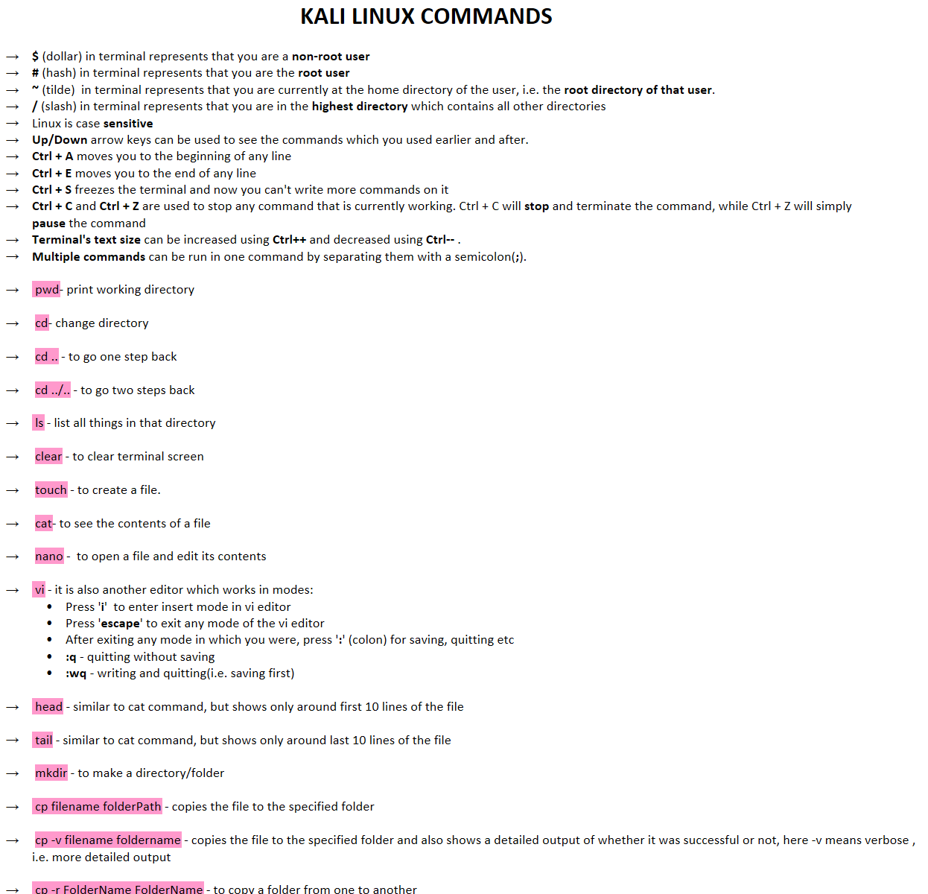)  
![ cp -r FolderName FolderName - to copy a folder from one to another

 mv file/folder folder - to move a file/folder to another folder (-r is optional here)

 rm FileName- to remove a file

 rm -r  FolderName - to remove a folder
ANYTHING DELETED/REMOVED USING TERMINAL DOESN'T MOVE TO TRASH AND IS PERMANENTLY DELETED

 cat FileName | grep d - searches and prints the lines which contain small d in the file

 cat FileName | grep -i d -  searches and prints the lines which contain small or capital D/d in the file( because -i means ignore the case.

 CommandName --help - shows all the information about the command and shows all its switches( like -i is a switch in grep) and what do they do.

 man CommandName - shows a complete manual of the command as a text file ( press q to quit the manual)

 history - command to see what all commands have we previously typed

  id - shows information about user and user groups

  whoami - shows who is the current user

  ps - shows all the processes which are currently active

  ps -aux - shows all details of all currently active processes

 uname - tells which OS are you using( in general)

 uname -a - tells all the information about the OS you are using

  ifconfig - gives the configuration of the interfaces, can be used to find Ip addresses

  uptime - shows for how much time the system has been up.

  locate swastik - searching for a keyword, i.e.  it will locate all things where the keyword swastik is found

 find / -name FILENAME - searches for the file in the entire system and gives the path to it

  whereis ProgramName-  Used to find a specific program

 zip ZIPNAME FILENAME - will zip the file as the zipname

  unzip ZIPNAME - extracts the contents of the zipped file
ALWAYS USE EXTENSIONS ALONG WITH THE FILENAME like .zip, .txt etc

 shutdown - will schedule a shutdown of your system after a minute
 shutdown -c - will cancel the scheduled shutdown
 shutdown now - immediately shutdowns the system

  sudo CommandName - superuser do, means that if a command can't be run by a normal user, then without switching to the root sudo will help us run it.
 su USERNAME - switches to the specified user, if we don’t specify any user then it will switch to user by default.
 sudo su - switching to the root using your own password.

 ls -la  or ls -lh - to list all things with all details like permissions, size and type
](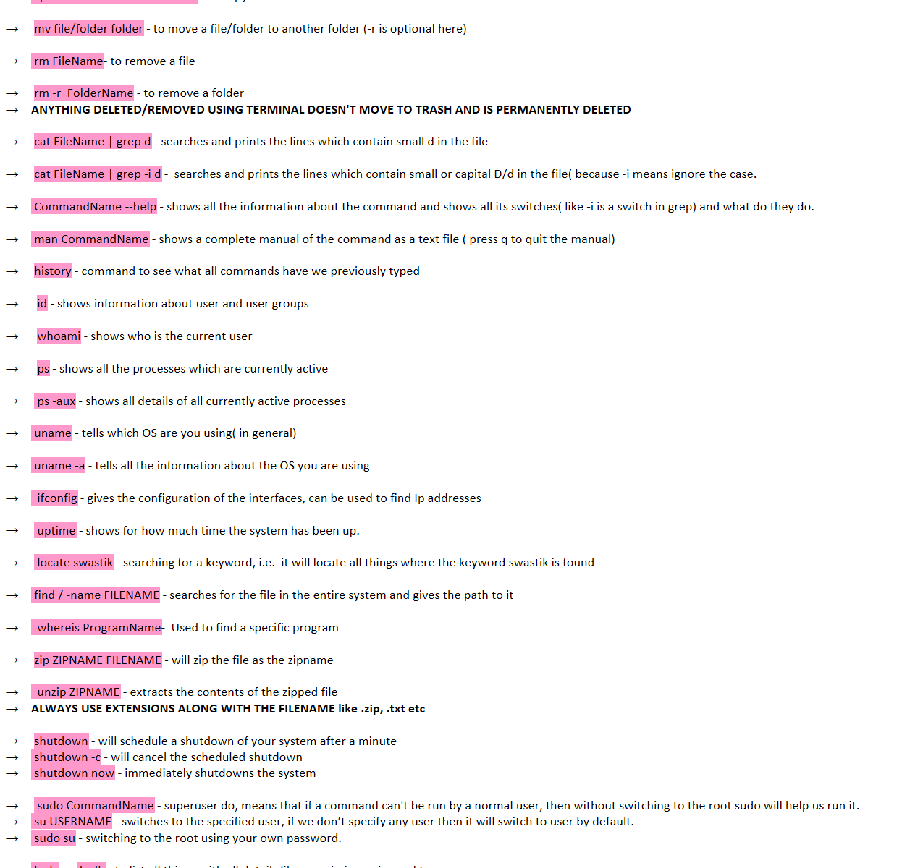)  
![ ls -la  or ls -lh - to list all things with all details like permissions, size and type
 d in first place of permissions represents directory
 - (dash)  of the first place only  in permissions represents file

 chmod NUMBERS filename - to change the permissions of the file using corresponding numbers
0   =  No permissions
1   =  Execute  =  x
2   =   Write   =   w
3   =   2+1      =   Write + Execute  = wx
4   =    Read   =  r
5   =    4 + 1   =    Read + Execute = rx
6   =    4 + 2   =    Read + Write = rw
7   =    4 + 3   =    Read + Write + Execute  = rwx
                 
               __   __   __
                 
                                                                     users outside the group (outside world)




For example -  000 means no permissions  to all                                                              i.e. --- --- ---
                          777 means all permissions to all                                                                i.e. rwx rwx rwx
    100 means execute permission to user and no permission to rest      i.e.  --x --- ---
    755 means all permissions to user and only read &execute 
            permission to the rest.                                                                         i.e.  rwx r-x r-x
                          264 means write permission to user, read & write permission to
 the user group and read permission to the outside world.           i.e.  -w- rw- r--

 So, the command looks like  ->   chmod 755 FileName

 chown NewOwner FileName - to change the owner of the file, if this change involves root, then you have to login as the root and do the changes.
 chown  :NewOwnerGroup FileName - to change the user group of the file, write it after a colon
 chown NewOwner:NewOwnerGroup - to change both owner and owner group of the file
 
adduser USERNAME - to add a new user to the system, can only be done by the root.
 sudo adduser USERNAME - to add a new user without logging in as root

 passwd - to change the password of the current user

 ping DomainName/IP - to check whether that domain is currently active/alive i.e. connected to the internet or not

echo TEXT > FILENAME - this will add the text you write to the specified file, NOTE THAT IT WILL OVERWRITE THE EXISITING CONTENTS.
 echo TEXT >> FILENAME - this will add text to the new line of the file

 apt install ToolName - this will install the tool specified, can be done by root
 sudo apt install ToolName - to install the tool without switching to the root

 sudo apt remove ToolName - to uninstall a tool, may leave some specially configured files
 sudo apt remove --purge ToolName - to uninstall each and everything related to that tool
 NOTE - here sudo is just to run command as the root, without actually logging in as root

 apt update - to update the list of tools which apt knows, and can download

apt upgrade - to upgrade the Kali Linux version to the latest
Ink Drawings
Ink Drawings
Ink Drawings
Ink Drawings
Ink Drawings
Ink Drawings
Ink Drawings
Ink Drawings
Ink Drawings
Ink Drawings
Ink Drawings
Ink Drawings
Ink Drawings
Ink Drawings
Ink Drawings
Ink Drawings
Ink Drawings
Ink Drawings
Ink Drawings
Ink Drawings
Ink Drawings
Ink Drawings
Ink Drawings
Ink Drawings
Ink Drawings
Ink Drawings
Ink Drawings
Ink Drawings
User/owner
Ink Drawings
Ink Drawings
User group
Ink Drawings
Ink Drawings
Ink Drawings
Ink Drawings
Ink Drawings
Ink Drawings
](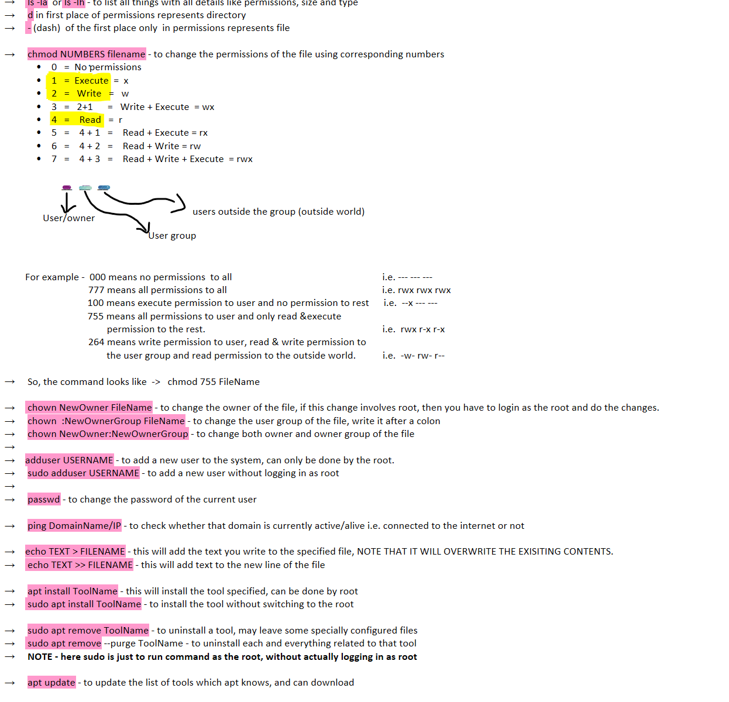)  
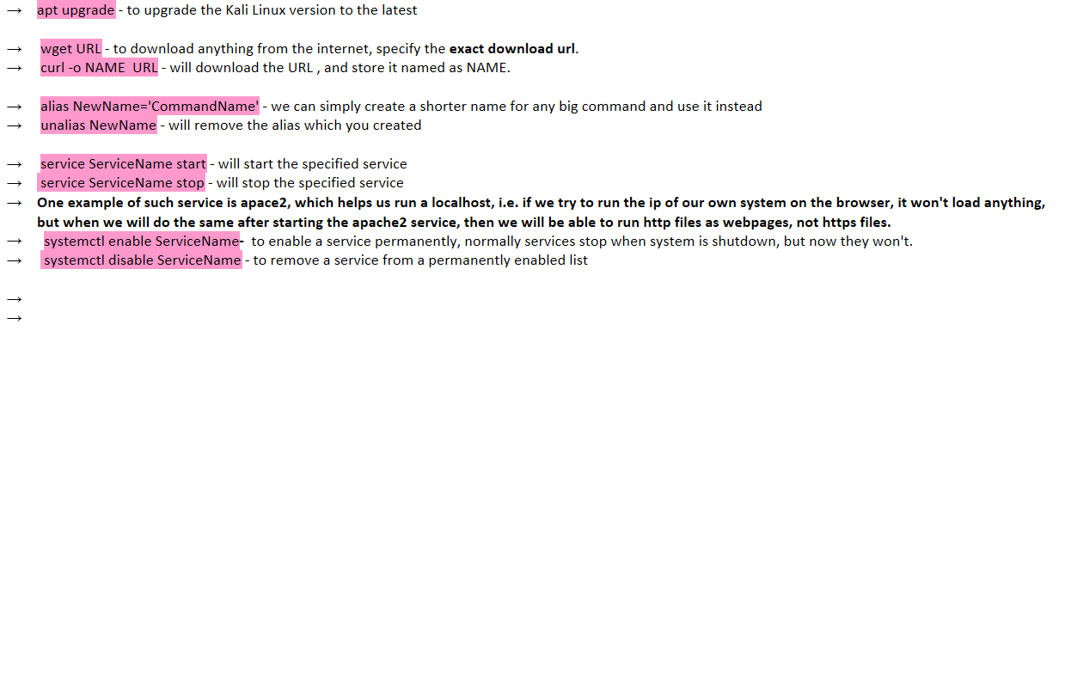

* + Windows is **NOT** case sensitive
  + **clear** command does not work in the admin command prompt. Instead use the command **cls**
  + **There is no direct command to create a file in windows, hence some methods to create a file are:**
    - copy NUL test.txt **-** basically it will create a file named test and copy null to it, i.e. an empty file will be created.
    - ANYTHING > test.txt - it will also make an empty file named test, though will give a warning about ANYTHING RANDOM which you would write, but the work will be done

* + type filename.txt - like we use cat filename in Linux to view the contents of the file, in windows we use **type** .

* + echo TEXT >> filename.txt - to insert content in the file.

* + copy con filename.txt - to make a new file and insert content inside it there only, to exit after insertion, press **Ctrl + Z**.

* + mkdir FolderName - to create a folder/directory.

* + dir - lists the contents of the current working directory
  + dir /a - to show all the contents of the directory, including hidden files.
  + dir /s - to show all the contents of the subdirectories also, including each and everything, hence a very **detailed search**.

* + tasklist - shows the all currently running processes in the system.

* + type filename.txt | findstr e - will search and print all the lines of the file which contain the letter e.

* + whoami - to see who is the current user
  + whoami /all - shows detailed information about the user
  + echo %username% - to see who is the current user.
  + net user - shows all the user accounts in the system.
  + net user USERNAME - shows all information related to that USERNAME.

* + systeminfo - gives all the important info related to the system

* + copy FileName CompletePath - copies the file to the specified location.
  + move FileName CompletePath - moves the file to the specified location.

* + del FileName - to delete a file.
  + rmdir FolderName - to delete a folder.

* + CommandName /? - to get the help regarding the command
  + doskey /history - to see the history of the commands that have been used.

* + **Reconnaissance** means Information Gathering
  + In **Passive** Reconnaissance, the target **doesn't get** to know that we have been searching something.
  + **SEARCH 'exploit db' in google to get more of such google dorks- and go inside google hacking database in it.**
  + **Search 'whois' in google to get domain information**

TIPS OF EFFECTIVE GOOGLE SEARCH

* + **"**Anything**"** - the keyword in specified in double quotes will give a precise search based on that.
  + **site:** SiteName "Anything" - to search anything from the specific site.

* + **inurl:** Anything - to search anything in the urls of a specific site.

* + **intitle:** Anything - to search for anything contained in the title

* + Search '**Builtwith**' on google which would tell the technologies on which the various websites are running on.
  + Search '**Robtex**' on google which would tell various info like Ip addresses, domain names etc of the websites you search for.
  + Search '**intodns**' on google to get the DNS Configurations and health status of the target websites.
  + Search '**ssllabs**' for testing our SSL server's health.
  + Search '**Security Headers**' for checking the security of the http headers, mostly the missing headers.
  + Search '**Social Searche**r' to search the about all the social medias of the target.

* + Search '**shodan**' which is an IOT search engine and helps to access various IOT devices like cameras and stuff.
  + Search '**wayback machine**' which gives us the information and history of all the webpages in the world, even if they have been deleted.
  + Search '**osint framework**' which is an information gathering framework, to get any information about any topic
  + Write **/robots.txt** after any website which tells search engines that what they can index in their search results and what they cannot.
  + Write **/sitemap.xml** after any website which tells us the flow of the site like how many and what all webpages it contains. ( it may not be present/accessible in some sites)
  + Search '**maltego**' which is also a popular information gathering framework/tool. - learn about this tool.

Active Information Gathering/Reconnaissance is the exact opposite of Passive Rec.

It involves intrusive searches, i.e. we interact with the target to get more information.

Download Pentest Box

Use **scanme.nmap.org**.

Commands:

* **ping** TargetIP - to check whether the target is alive or not.
* **nslookup** - tool for checking many DNS record services
* 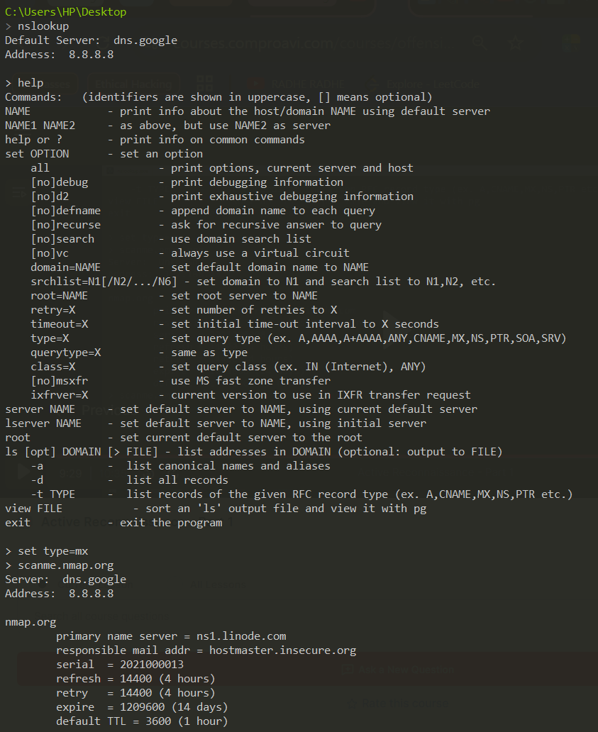

* 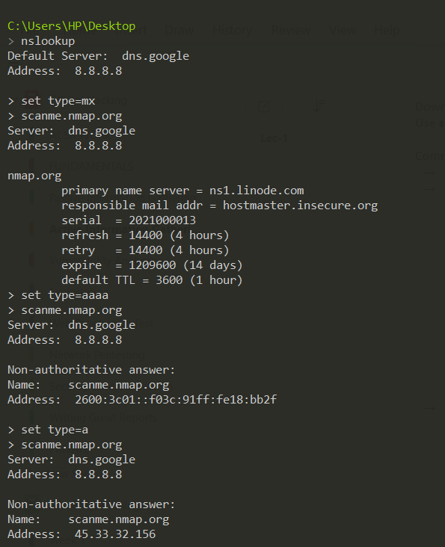

User **nmap.org** to learn about the nmap tool

**COMMANDS:**

* **nmap** TargetIp/DomainName - it scans the target and gives some ports, state and services( base scan, checks around top 1000 TCP Ports)
* **nmap** TargetIp/DomainName **-sn** - like a ping scan, and tells whether the target is alive or not along with its MAC address
* **nmap** TargetIp/DomainName **-sS** - it is the default TCP port scan, also called the steal scan in the nmap, it will show the number of TCP ports, their state and service.
* **nmap** TargetIp/DomainName -**sT** - the TCP connect scan, can be used when we are not allowed to do the -sS scan, hence in this now we need not have the root privileges to do the scan.
* **nmap** TargetIp/DomainName **-sU** - the UDP scan, very slow scan
* **nmap** TargetIp/DomainName **-A -**  scans for scripts, trace route, detecting OS and service number versions.
* **nmap** TargetIp/DomainName **-v or -vv or -vvv or -vvvv** - gives a detailed scan for the IP, more the number of v's, more detailed verbose comes as output.
* **nikto -h** TargetIp/DomainName - this tool is also to get details of the target which might be useful during the attack.
  + **testphp.vulnweb.com** - it is also a demo website to perform various scans
  + **dirbuster**  is a tool which we are using to find & scan directories and files in a website, by setting various options, hence it searches various combinations and gives us the names of directories which we can use to find vulnerabilities.
  + If we know that our target is using WordPress, then we can use a tool called **wpscan** to do various scans and find vulnerabilities in it.
  + **hackertarget** is an online scanner, which may also be useful.

Vulnerability Sites:

1. [www.securityfocus.com](http://www.securityfocus.com)
2. [www.zerodayinitiative.com](http://www.zerodayinitiative.com)
3. [www.cvedetails.com](http://www.cvedetails.com)
4. [www.tenable.com](http://www.tenable.com)

Vulnerabilities can be found anywhere, may be on the service, on the OS, on the application, on the plugins etc.

Select your target and google search it with the keyword "vulnerabilities"

CVSS - The Common Vulnerability Scoring System

Write CVSS nvd to go to the site of calculating the CVSS.

Sitename - nvd.nist.gov

**CVSS CALCULATOR**

* *BASE SCORE METRICS*- information provided by the vendor, which usually doesn't change.
  1. Exploitability Metrics
     + Attack Vector - It is simply the means by which the attack is carried.
     + Attack complexity - is how difficult it is to perform the attack.
     + Privileges required - are if you need some special access for the attack.
     + User interaction - is if a person needs to do something.
     + Scope - means that can this vulnerability be leveraged to access system or software that are beyond the scope of that system. If an exploit just exploits the single system, then the scope remains unchanged and Scope Changed means that does the vulnerability affect resources beyond the scope of that single machine or its means or privileges.
  2. Impact Metrics - is about how much the CIA Triad is affected.
     + Confidentiality Impact
     + Integrity Impact
     + Availability Impact

* *TEMPORAL SCORE METRICS* - depends on the level of knowledge you have about that vulnerability.
  + Exploit Code Maturity (E) - means if you have an exploit then how much mature is it , and how much do you know it will work
  + Remediation Level (RL) - means if a vulnerability has an official fix at that moment or not
  + Report Confidence (RC) - means how much confidence you are that your target has got this vulnerability.

* *ENVIRONMENTAL SCORE METRICS* - It is generally the specific score about the target organisation , different from the base score metrics because it has specific data about the specific situation unlike base score metrics which uses general information. It has an additional metrics called *Impact Subscore Metrics* along with the Exploitability and Impact Metrics.
  + 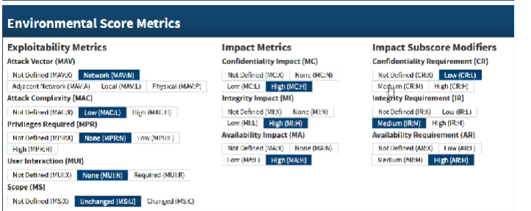

***AUTOMATED ASSESSMENT***

* OpenVAS
* Nessus - for doing network vulnerability assessment
* Nexpose
* Vega - for doing website vulnerability assessment
* Arachni
* <http://localhost:8834/WelcomeToNessus-Install/welcome>
* Watch this lecture again if you forget the scanning part, do it for revision again
* tempmail is a site to generate temporary email ids

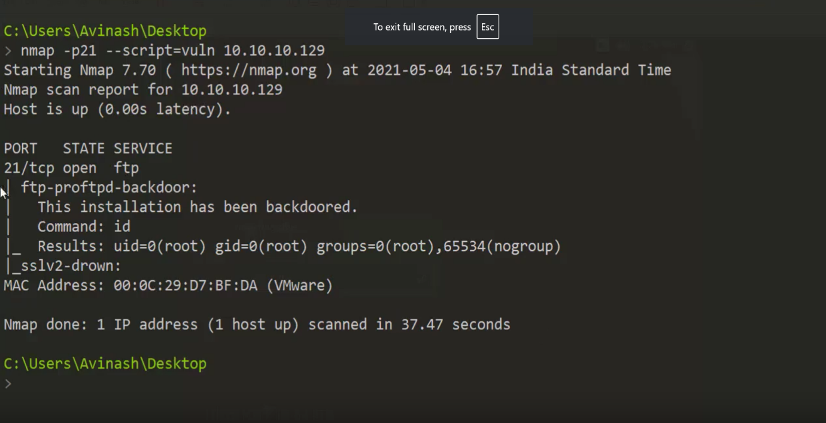

* testphp.vulnweb.com - site for demo attacks

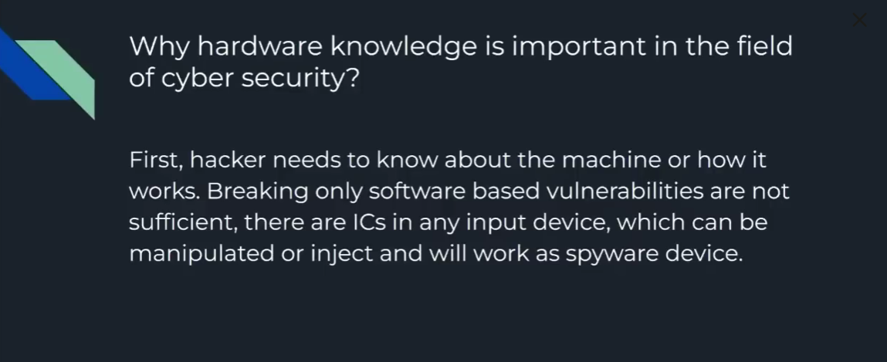

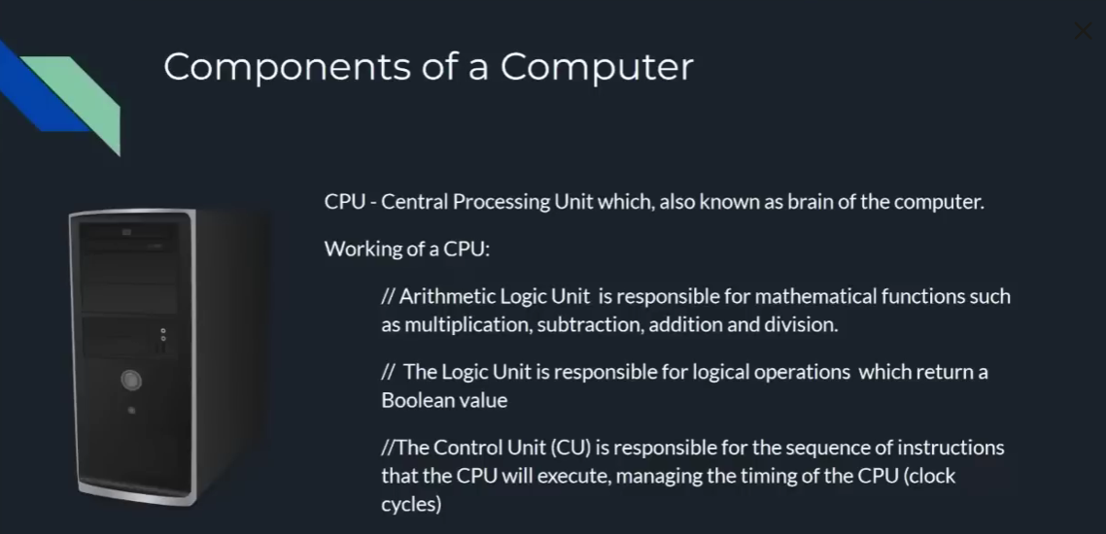

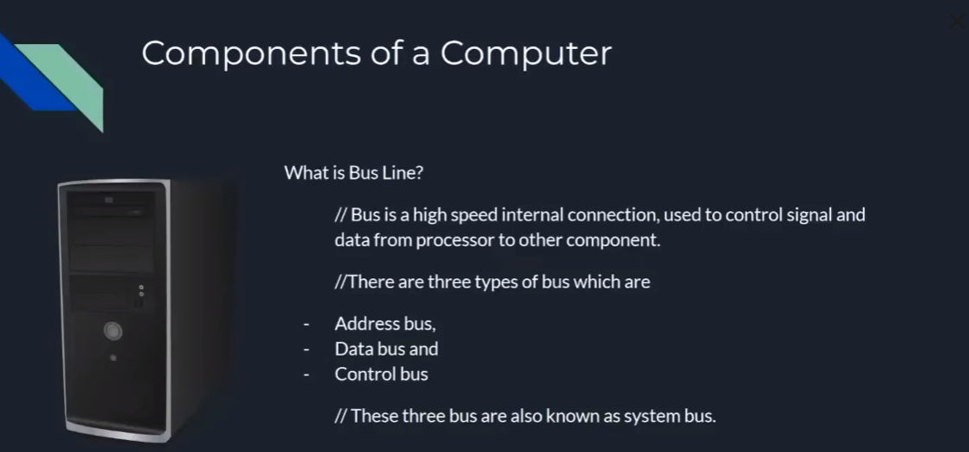

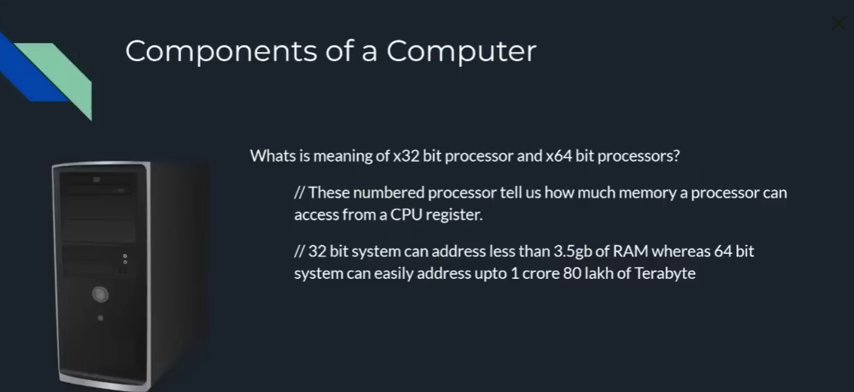

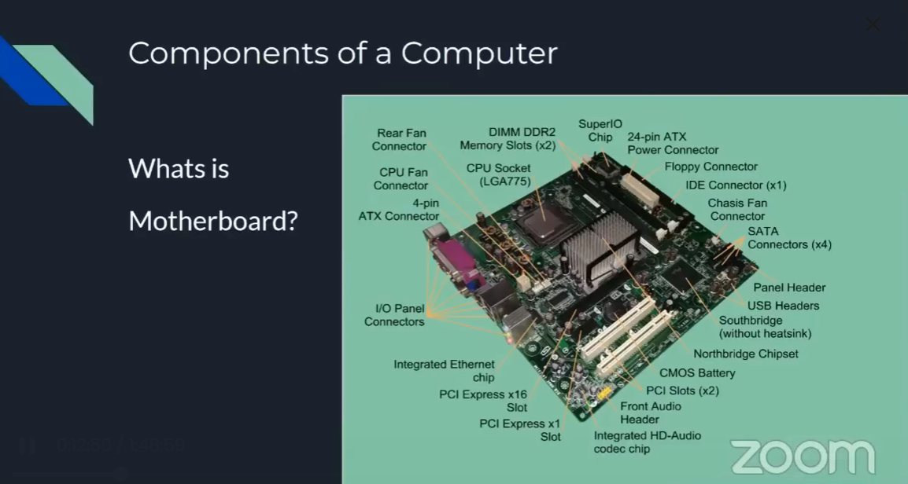

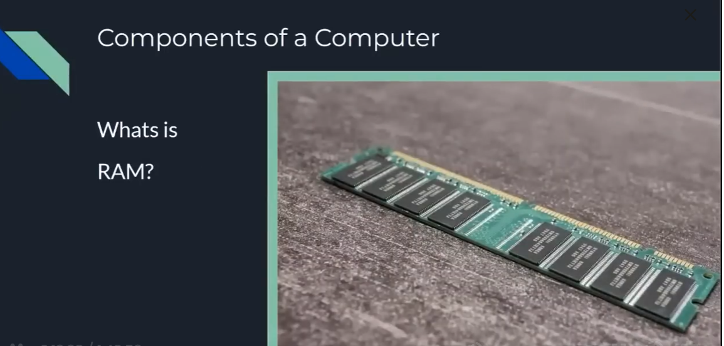

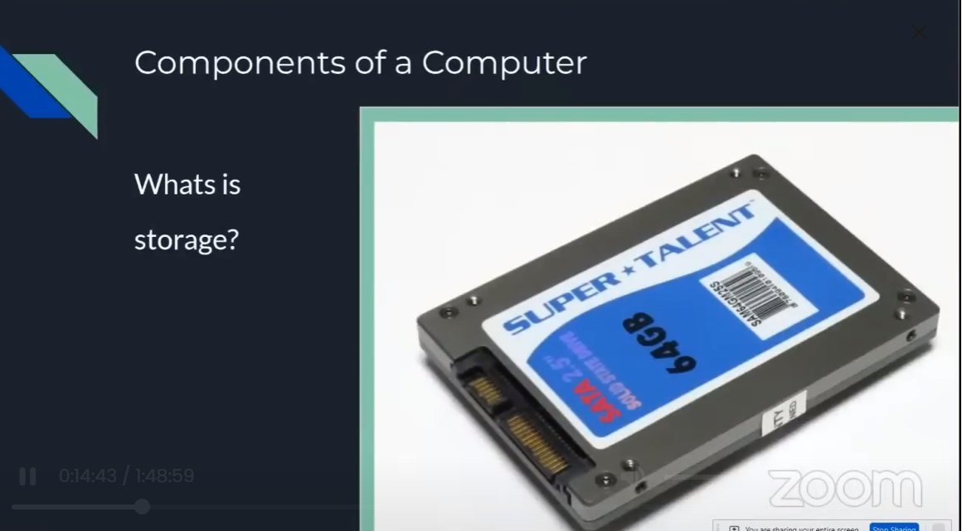

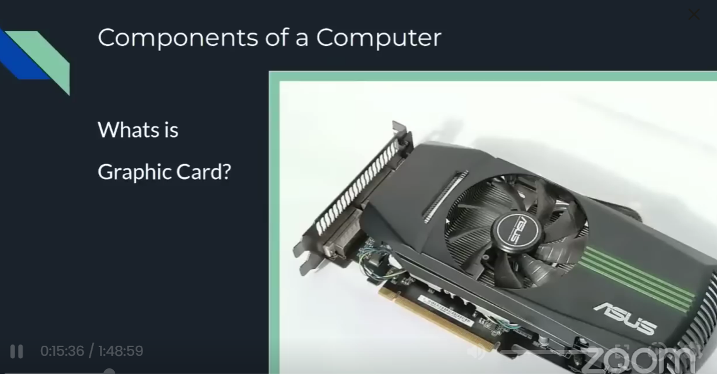

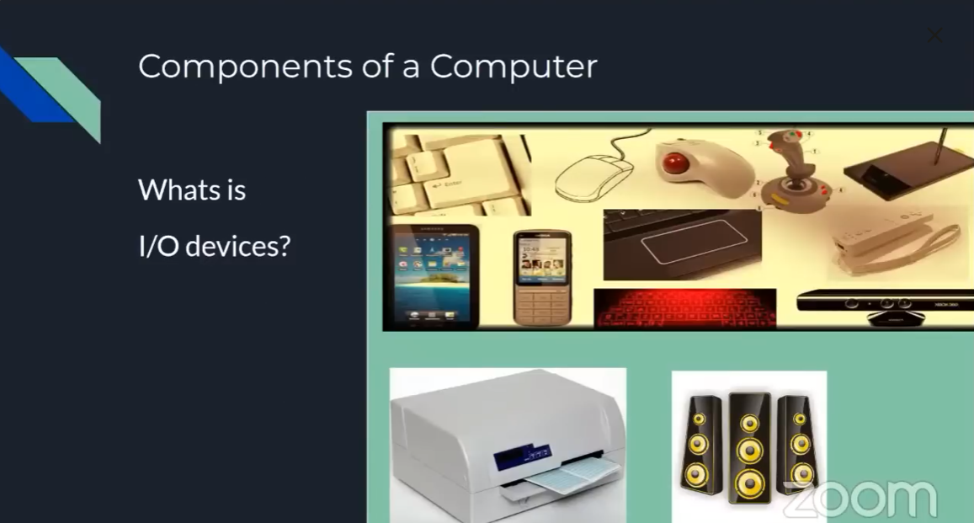

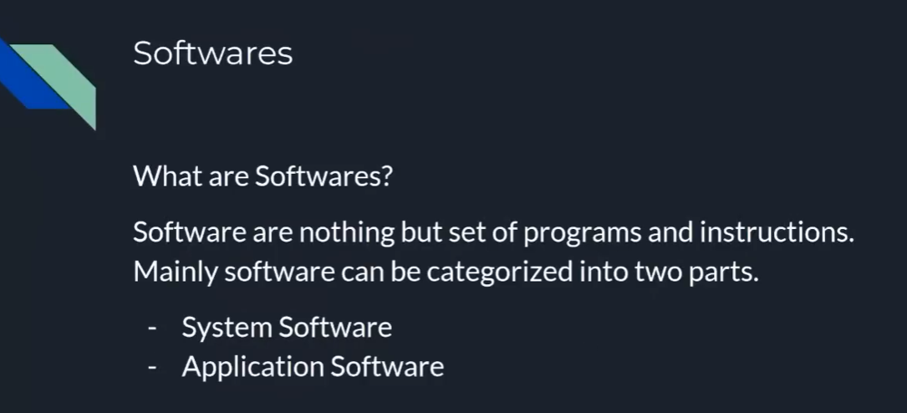

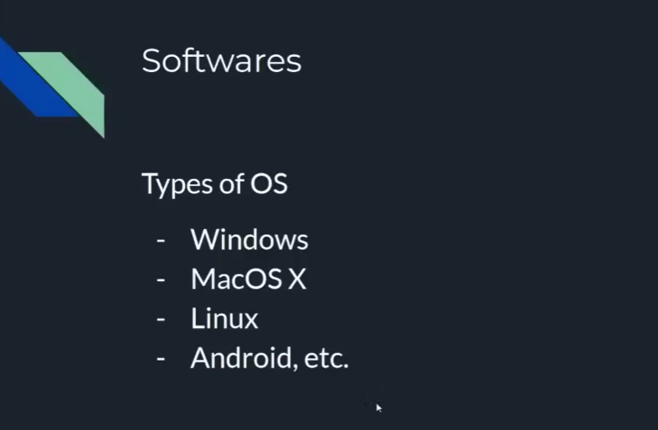

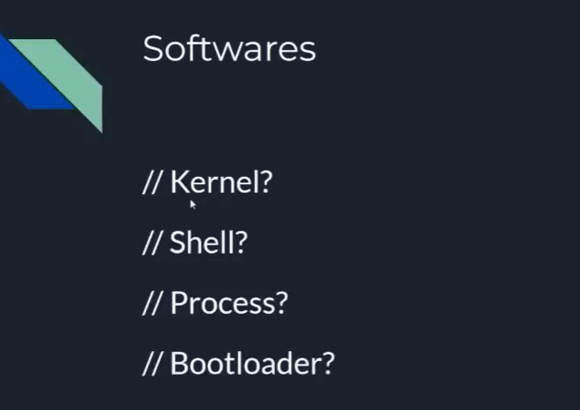

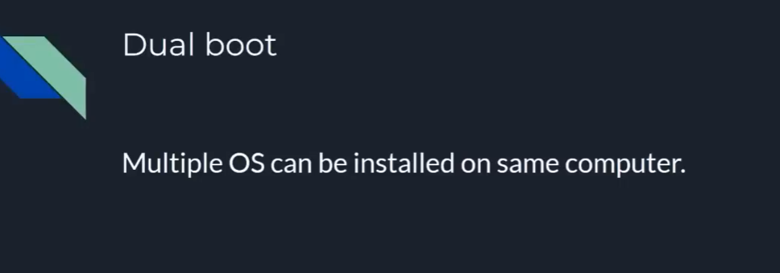

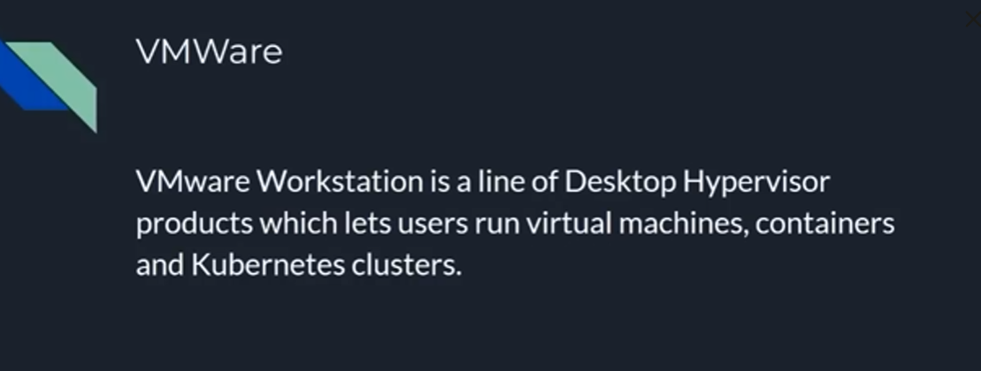

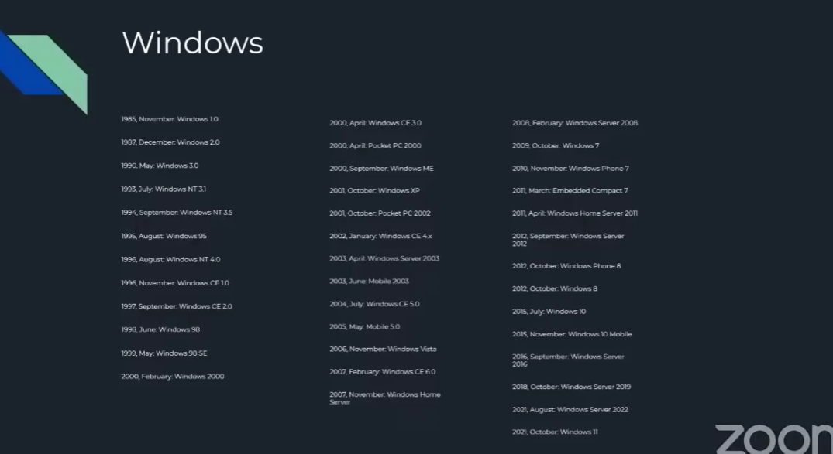

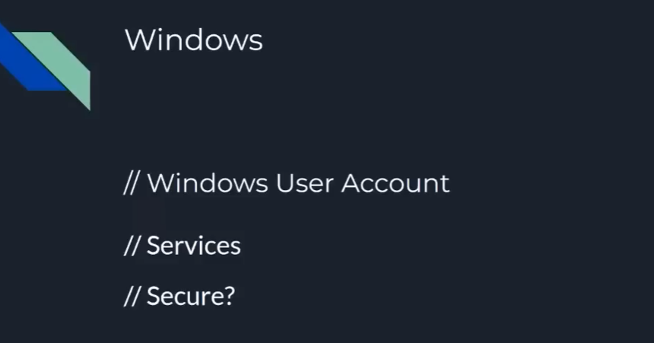

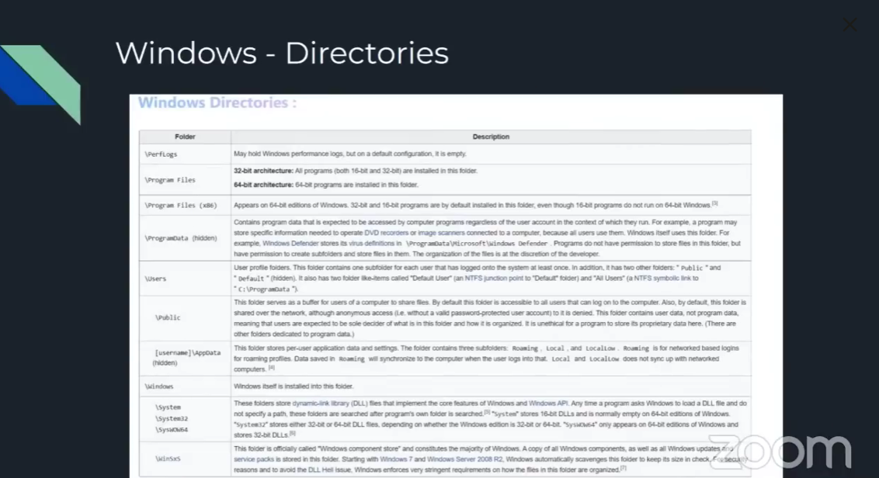

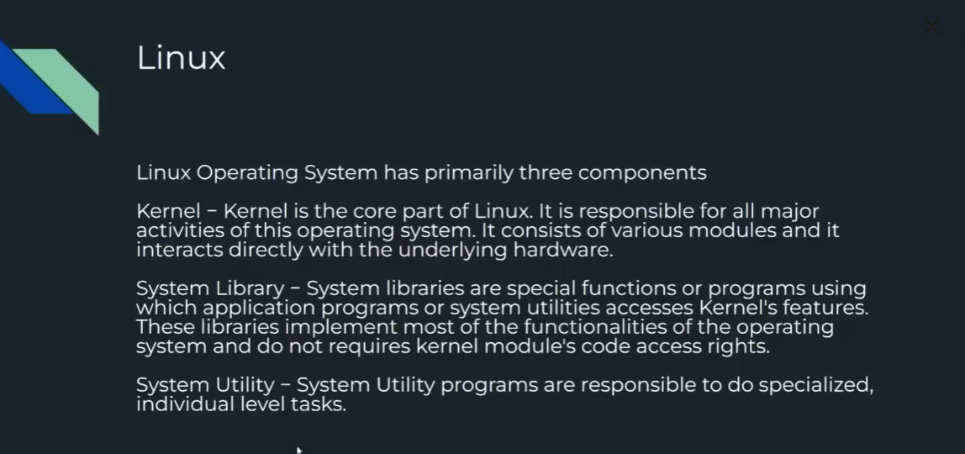

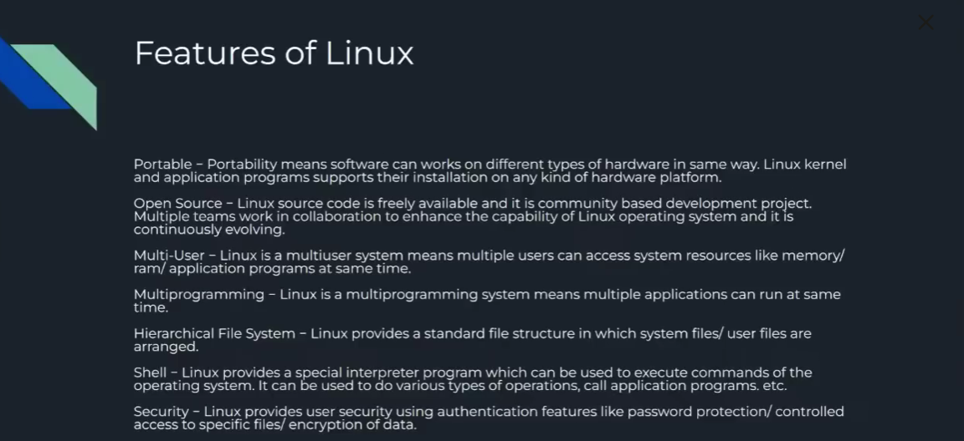

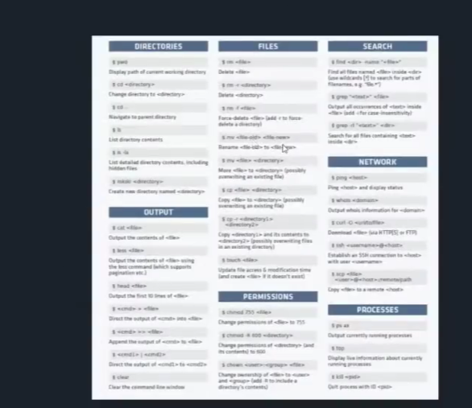

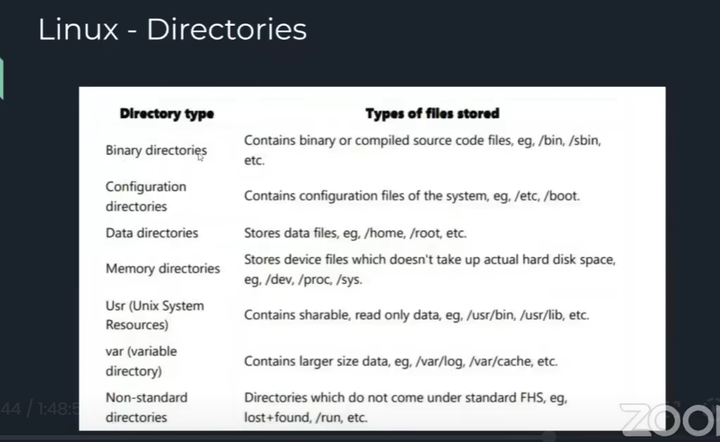

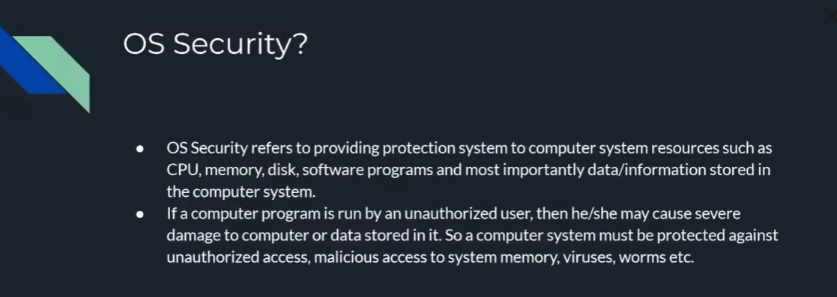

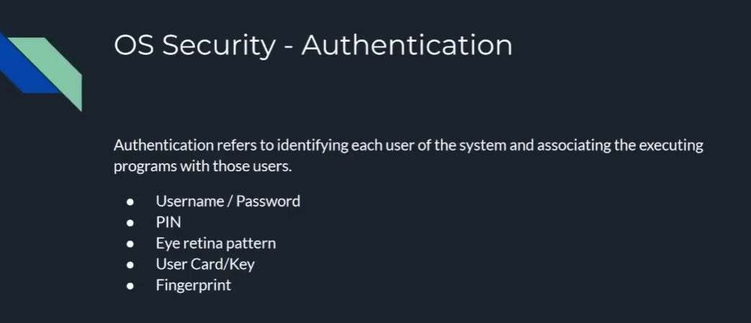

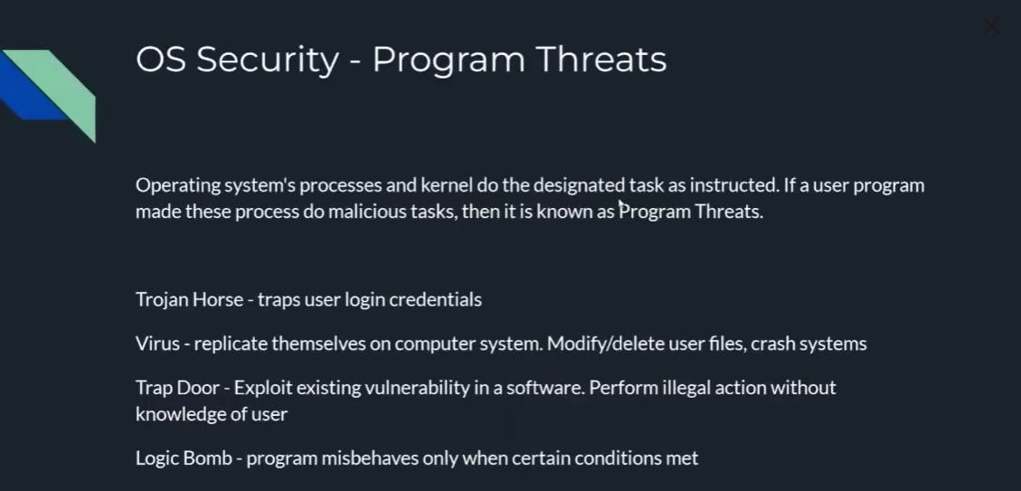

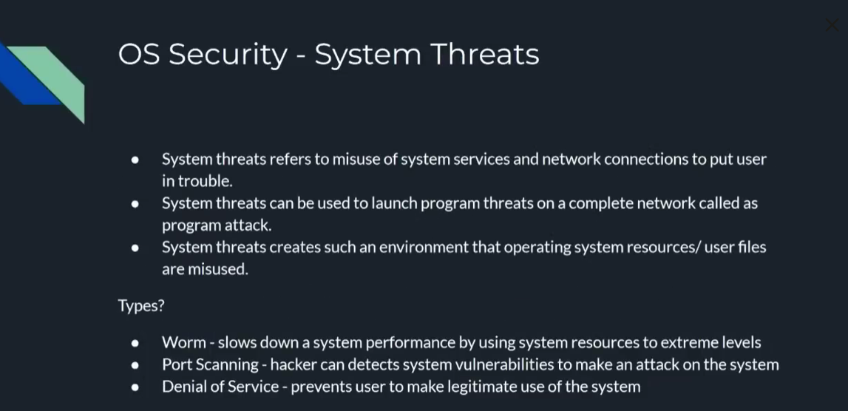

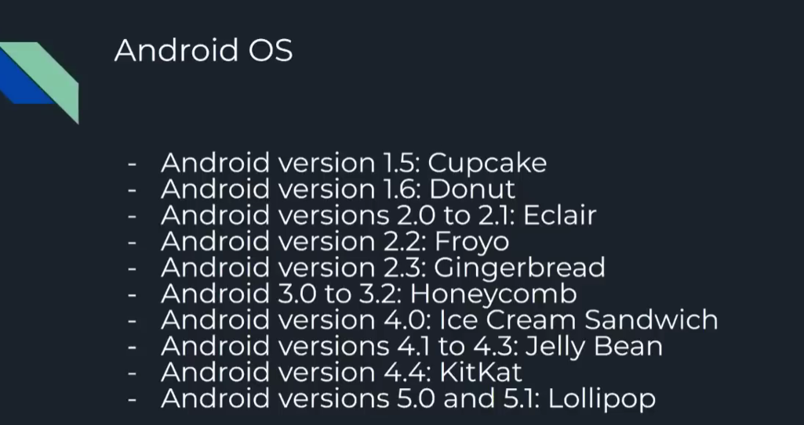

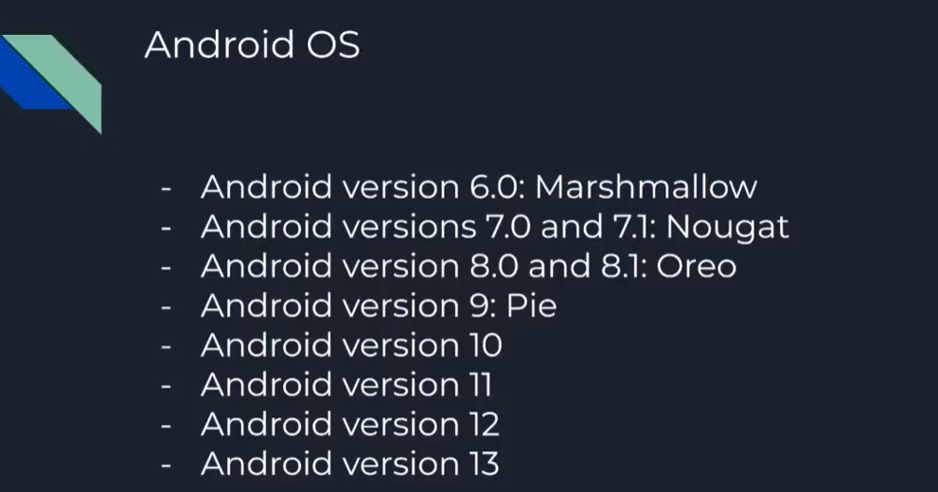

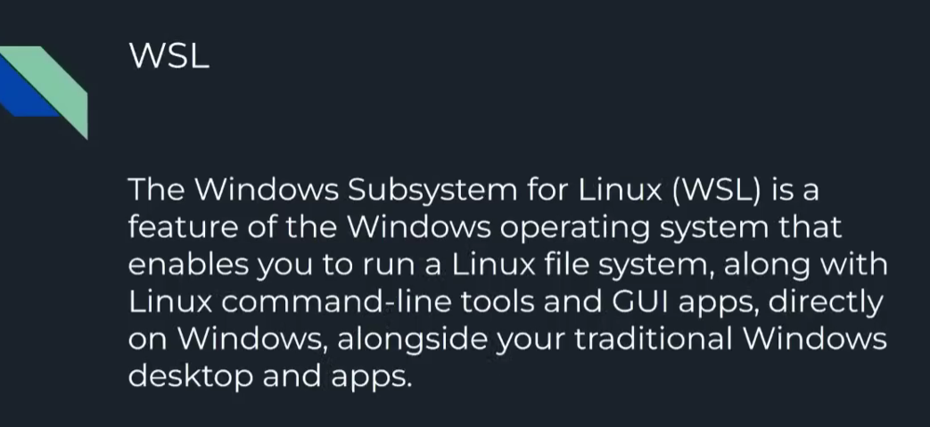

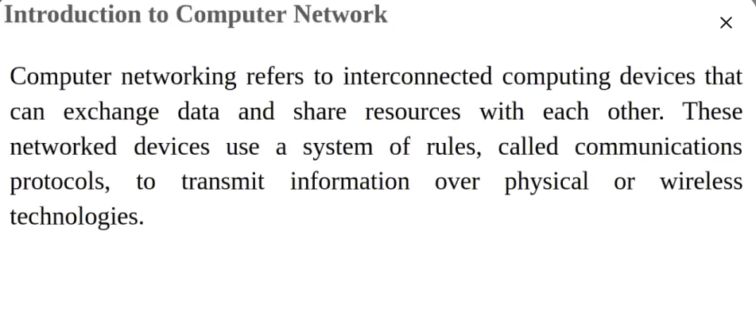

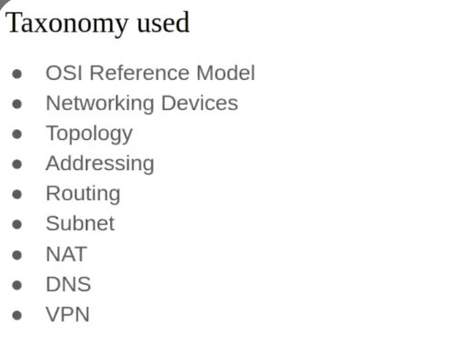

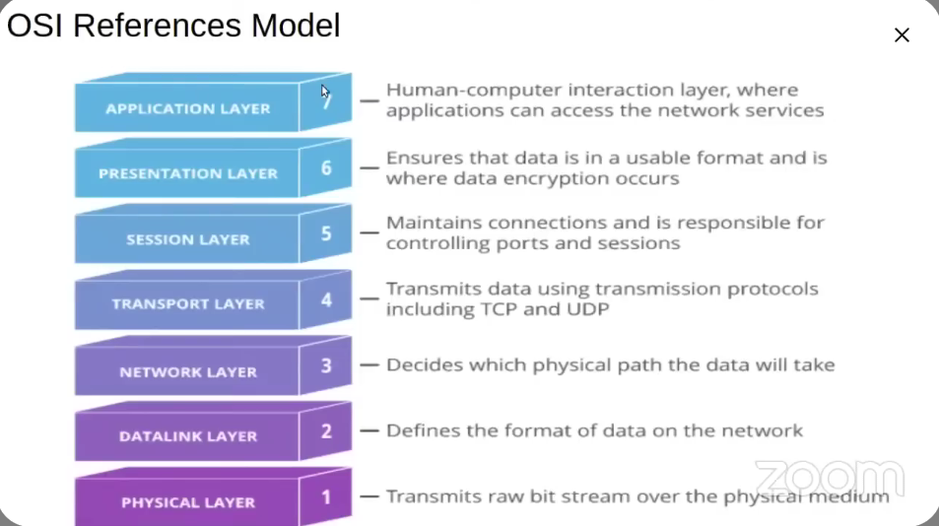

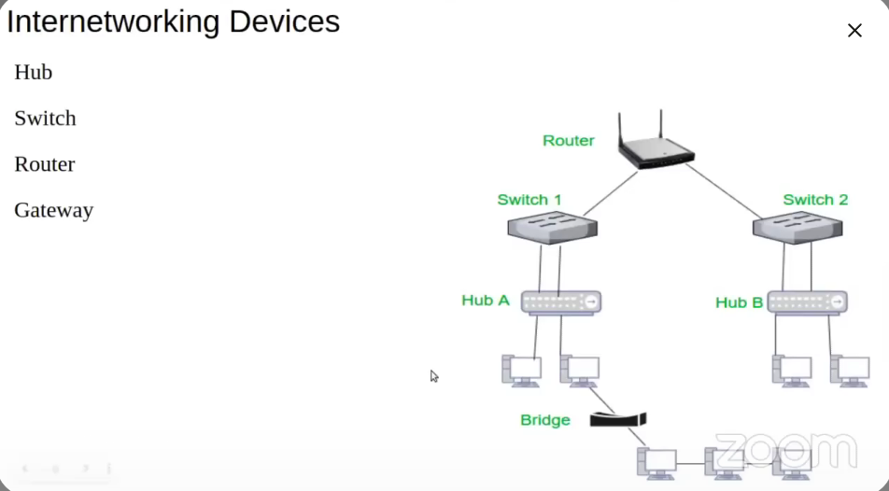

Sites for information gathering:

DNSDumpster.com

Shodan.io

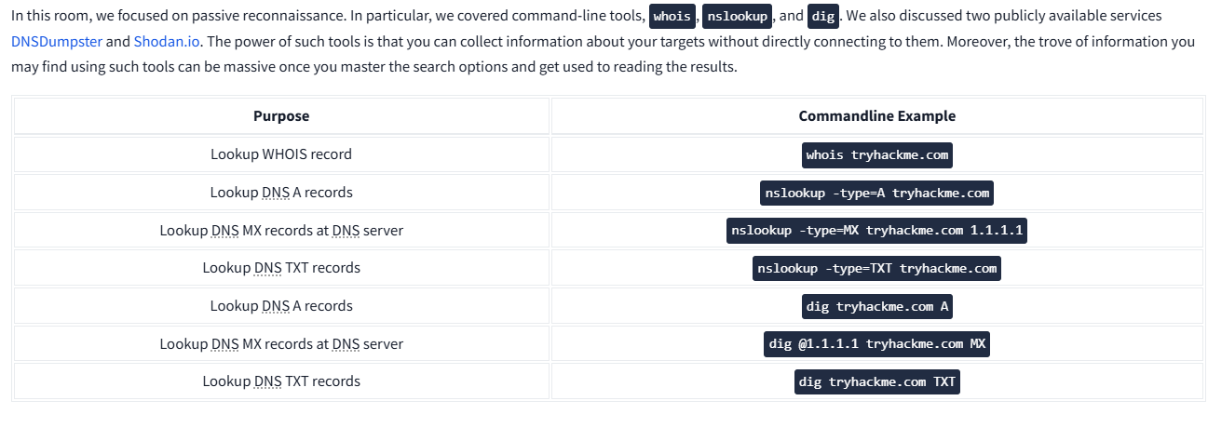

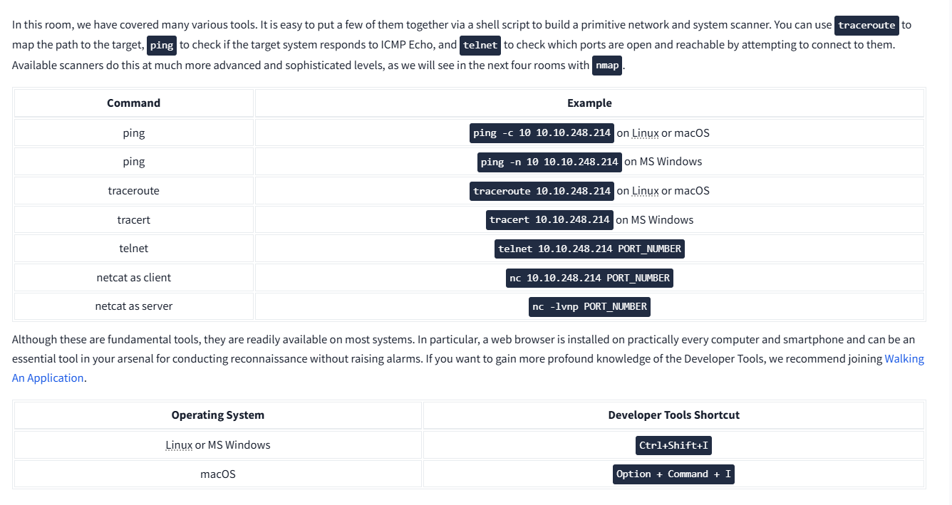

Exiftool - to get info from various file

Wigle.net - site for info gathering (got the ssid of the wap from bssid)

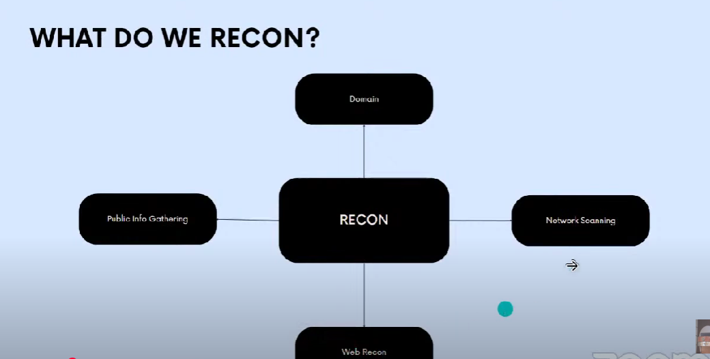

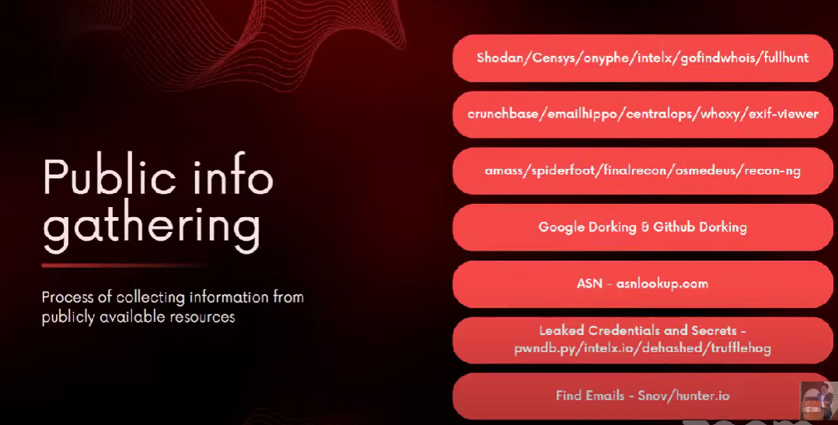

* 1. To understand the company and get root domain - crunchbase (2nd box in pic)
  2. To find emails related to the company - last box of the above pic
  3. Now, to verify whether the emails are real or not - emailhippo (2nd box in pic)
  4. To get the access of internet connected devices of an organisation - shodan (1st box in the pic)
  5. Another tool to get various usernames, passwords etc is intelx.io
  6. Next tool is to get metadata from images - exif viewer(2nd box in the above pic)
  7. Google dorks - ***site: " "***  or ***intext: " "***  or ***inurl:" " ..*** To search only in specific site or search by intext or search by keywords in the url respectively… to find more such google dorks, go to the Github repository by provisec.
  8. Use Github dorks also
  9. asnlookup.com - ASN stands for Autonomous System Numbers, using them we can get private IP Addresses
  10. Use command line tools like trufflehog to scan github repositories and many more sites to get leaked or sensitive information.
      1. 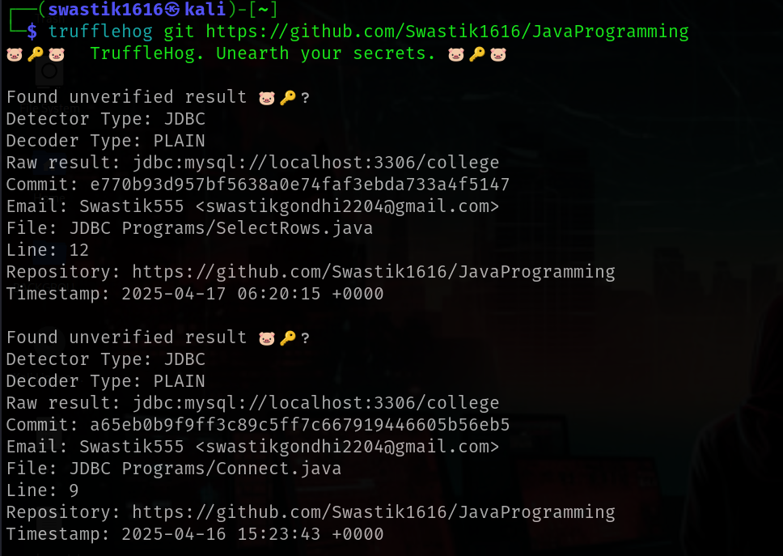
      2. 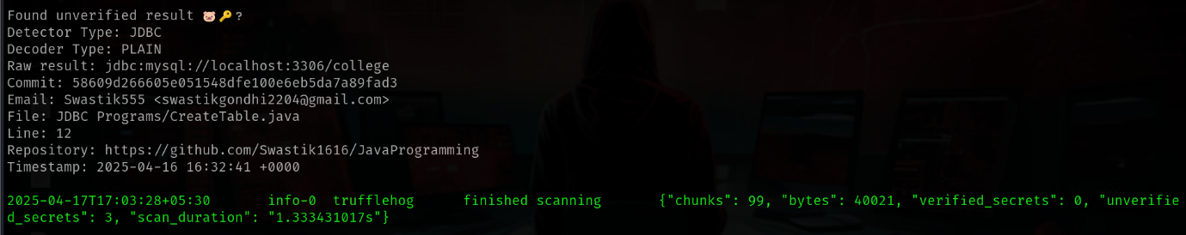

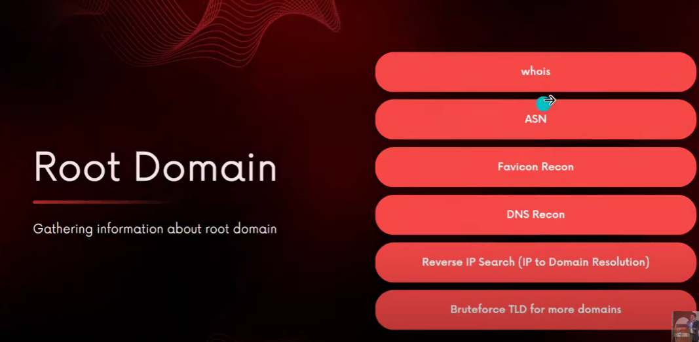

* 1. The small icon on each sites' top is called favicon icon. Using that icon we can calculate a favicon hash and then do reverse search on shodan using that icon and it will show us all IP's which are using that icon which may help us to get more information just from that icon.
  2. Reverse search an IP to get more domain names from that which belong to the same Ip, just write Ip to domain, and then find various other domains with different TLDS like .com , .co.in , .net , .de etc

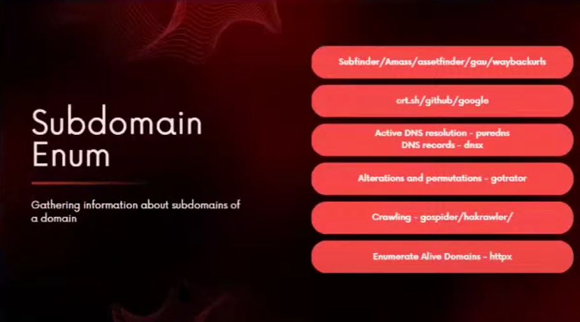

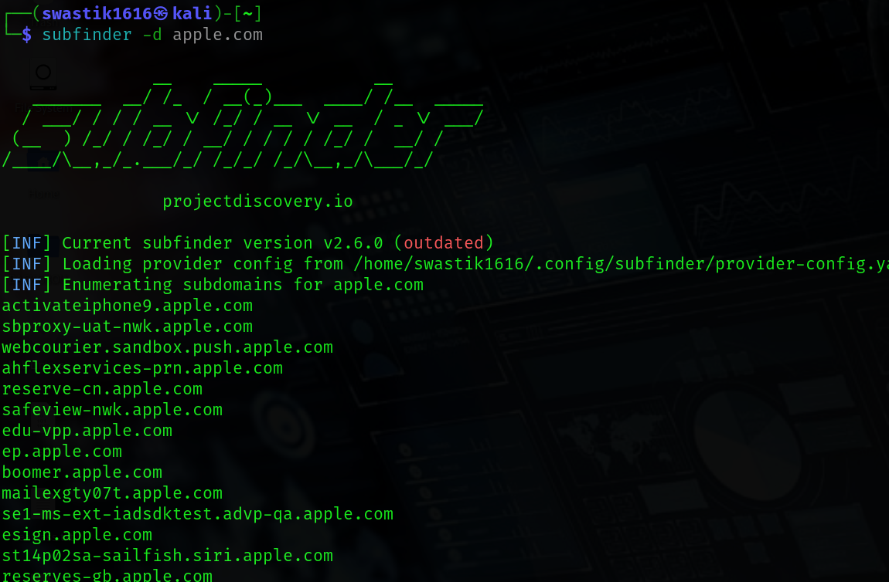

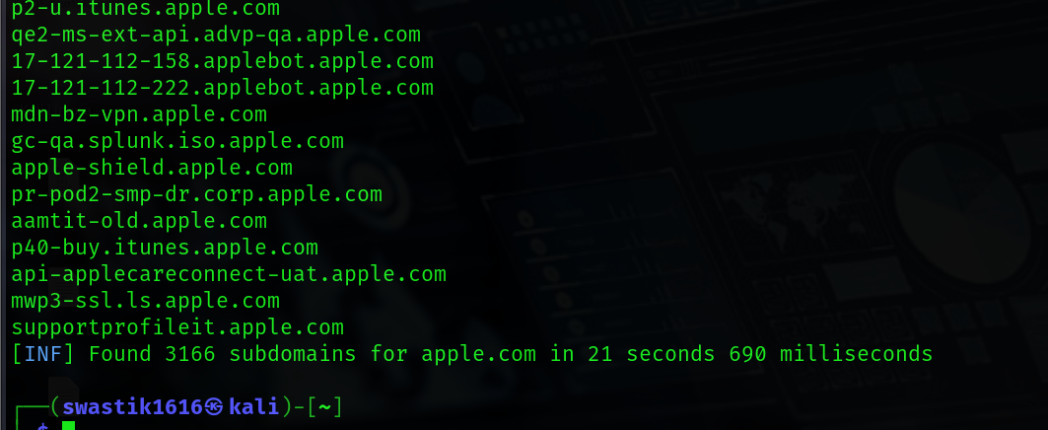

* 1. Now, because ***subfinder*** has helped us find so many subdomains, we can't check them manually one by one, so we will use a tool called ***gowitness*** which will help us in screenshotting all the webpages if we provide the urls to it as a list.
     1. Another tool for finding the subdomains is ***assetfinder.***

* 1. ***crt.sh*** is a site to find certificates of a particular domain.. Or you can also use tool called crtsh.py after downloading it from Github.
  2. We can also use the command ***github-subdomains -d DomainName***  to find many subdomains
  3. ***amas*** is also a wonderful tool for reconnaissance of various things. It can be used in Kali Linux CMD.
  4. Everything till now was passive enumeration i.e. searching the sources which already exist . But if we want to do active enumeration to search whether a source is alive or not at this moment then we can use a tool called ***gotrator***. It’s a wonderful tool which would try all permutations and combinations to find various subdomains etc.
  5. ***hakrawler***  is a tool which helps us find all the urls present in the source code of a website at one place and then we can use them further.
  6. ***httpx*** is a tool which will help us find that the subdomains which we have found are actually alive or not.

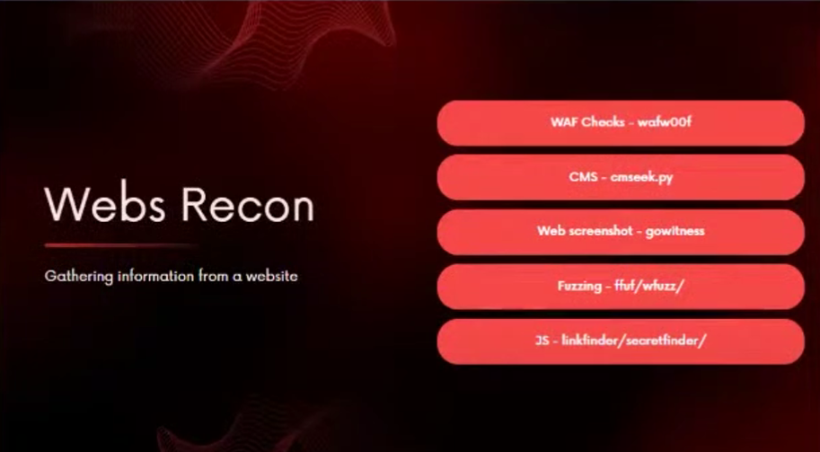

* 1. **ffuf** is a tool used for directory busting - The syntax is : ***ffuf -u URL/FUZZ -w WORDLIST.***
     1. Now, an important point to be noted here is that it is possible that the tool lists directories which don’t even exist, such directories can be identified by looking at the ***size,*** which would be ***zero*** for such directories.
     2. Also if we don’t want to list such directories in the output then we can filter out them using the command:
        + ***ffuf -u URL /FUZZ -w WORDLISTS -fs 0 .*** Hence this (-fs) switch would now filter size and not list any directory with size 0 in the output.
  2. Search for keywords like ***.js, aws, main, app, secret, api, key, AIZA, AIKA*** in source codes of websites to get vulnerable information.
  3. ***linkfinder*** is a tool to enumerate various JavaScript files.

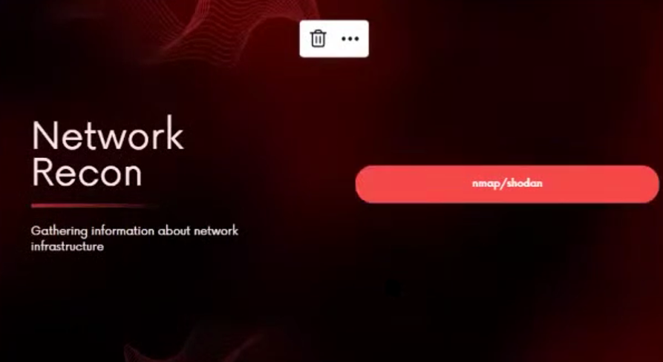

* 1. ***nmap*** can be used to find the open ports of a website
     1. ***nmap IP/Domain -*** to send pings to the Ip and also find open ports. It may be blocked if the site doesn’t allow to send pings.
     2. ***nmap IP/Domain -Pn -*** So we can use this switch (-Pn) which will now not send ping to the website and scan only the open ports and the website won't know.
     3. ***nmap IP/Domain -p-*** - to scan all the ports

* Exploitation is the process where we utilize the exploits in order to validate the vulnerabilities which have been identified.
* Exploit is a piece of code which abuses the Vulnerability to violates the:
  1. Confidentiality - means disclosing some sensitive information
  2. Integrity - means modifying or altering some sensitive information
  3. Availability - means something is not available to the authorities
* If any of these 3 are violated in the process of exploitation then we can say that the exploit was successful in abusing the vulnerability.
* The basic goal of exploits is to compromise the victim by taking advantage of the vulnerability and then delivering the payload into the target, that payload will do whatever should happen after the victim is compromised.
* A shell in hacking is one which will take instructions in form of commands from the user and will give it to the OS of the target. A shell grants us the ability to control the target. It can be both command line or graphical.

\_\_\_\_\_\_\_\_\_\_\_\_\_\_\_\_\_\_\_\_\_\_\_\_\_\_\_\_\_\_\_\_\_\_\_\_\_\_\_\_\_\_\_\_\_\_\_\_\_\_\_\_\_\_\_\_\_\_\_\_\_\_\_\_\_\_\_\_\_\_\_\_\_\_\_\_\_\_\_\_\_\_\_\_\_\_\_\_\_\_\_\_

* **Metasploit** is an open source Hacking Framework. It has an extensive library of exploits
* **vulnhub.com** - site to download various virtual machines to practice hacking

\_\_\_\_\_\_\_\_\_\_\_\_\_\_\_\_\_\_\_\_\_\_\_\_\_\_\_\_\_\_\_\_\_\_\_\_\_\_\_\_\_\_\_\_\_\_\_\_\_\_\_\_\_\_\_\_\_\_\_\_\_\_\_\_\_\_\_\_\_\_\_\_\_\_\_\_\_\_\_\_\_\_\_\_\_\_\_\_\_\_\_\_\_\_\_\_\_\_

***HACKING THE FIRST MACHINE USING METASPLOIT EXPLOITATION***

***Following are the steps :-***

* ***Doing Information gathering***

1. **sudo netdiscover** - to find the Ip of the target.

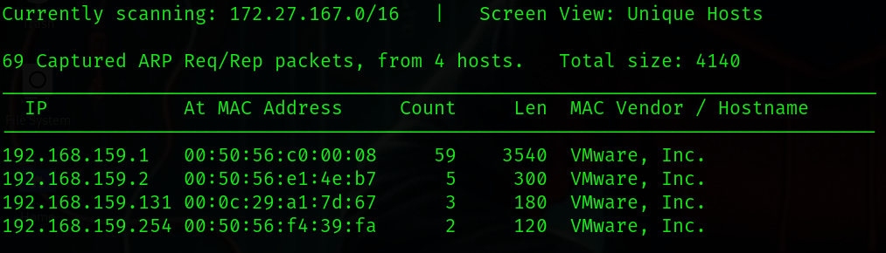

* ***Always ignore the .1 , .2 and .254 because they are not machines, they are router gateway subnet masks, hence the remaining Ip will be the target IP.***

1. **sudo netdiscover -r subnetmask** - to find Ip of the target ***when you are sure that the target is in the same subnet***, here to write the subnet mask just make last octet .0 and put /24… which shows that we have specified a particular range for scanning, it is done to save time.

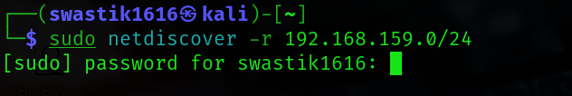

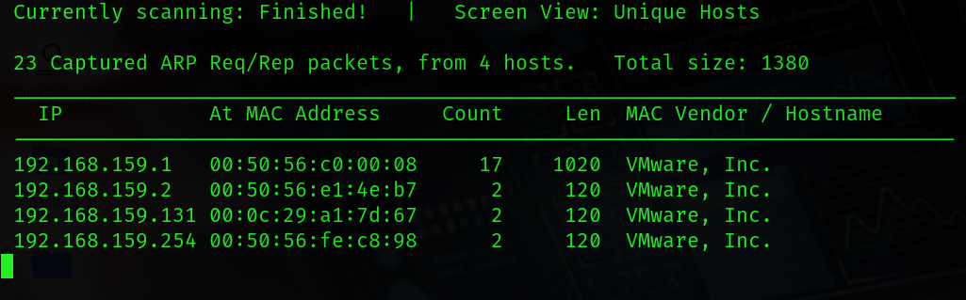

* ***Always ignore the .1 , .2 and .254 because they are not machines, they are router gateway subnet masks, hence the remaining Ip will be the target IP.***

1. **ping TargetIP**  - to check whether it is alive or not.

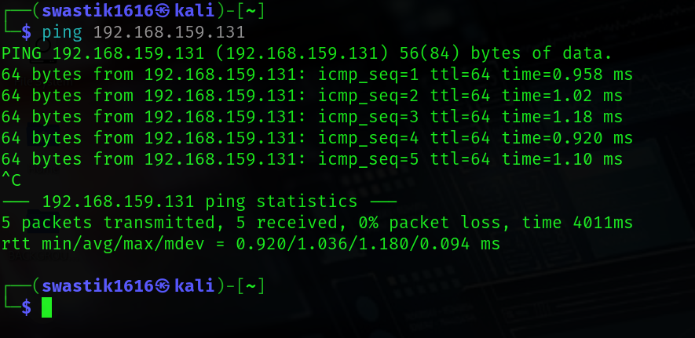

* We successfully received packets from the IP, which indicates that it is alive

1. **nmap -A -p- TargetIP** - Aggressive(-A) scan of each and every port(-p-) of the target

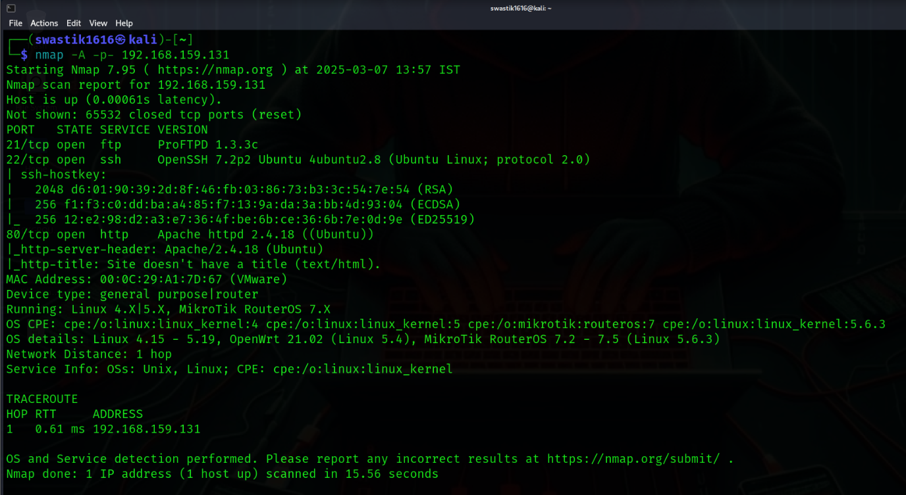

* We got 3 open ports 21,22 and 80 along with their protocols, service and version

* ***Doing vulnerability analysis***

1. **nmap --script=vuln -PORTNUMBER TARGETIP** - for doing vulnerability assessment before finding exploits

*This step is very important, many people directly jump to the exploiting part without doing it*

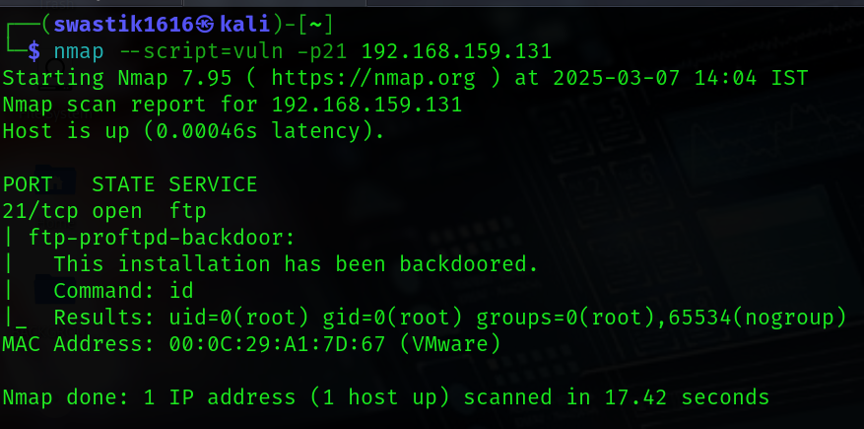

* We decided to do vuln assessment on port 21 which tells us that this installation has been backdoored which is a dangerous vulnerability and can even be exploited manually

* ***Finding exploits and performing the exploitation***

1. **msfconsole** - to open Metasploit for finding exploits



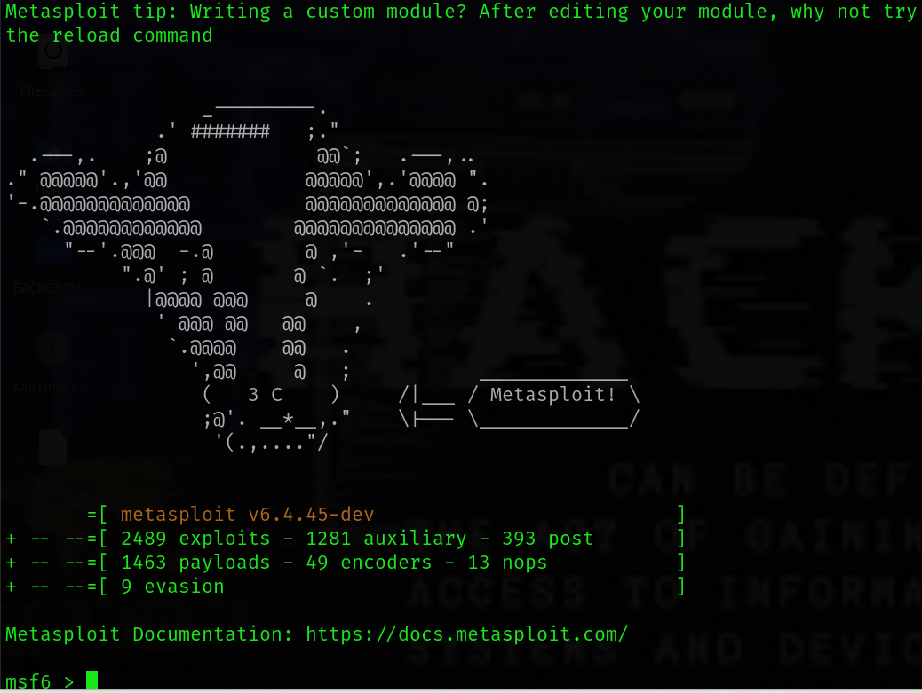

1. **search VersionOfPort** - to find the exploits

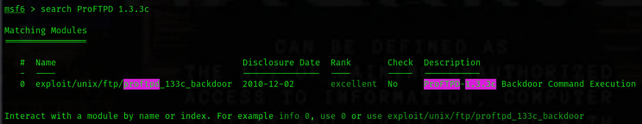

1. **search VersionOfPort type:exploit** - to find particular type of exploit

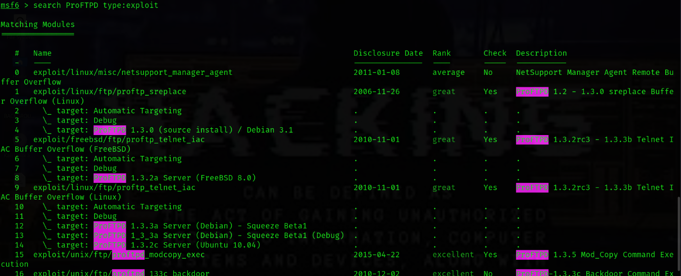

1. *then copy the path of the exploit*
2. **use ExploitPath** - to select the corresponding exploit and enter it

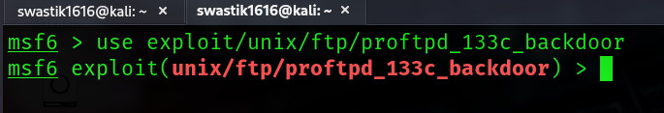

1. **info** - to get various useful information about the exploit

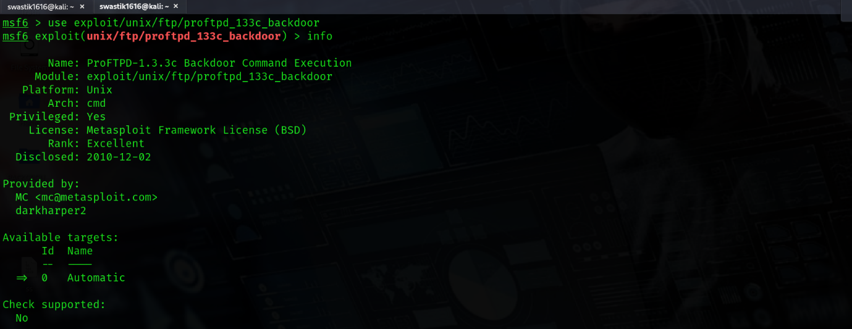

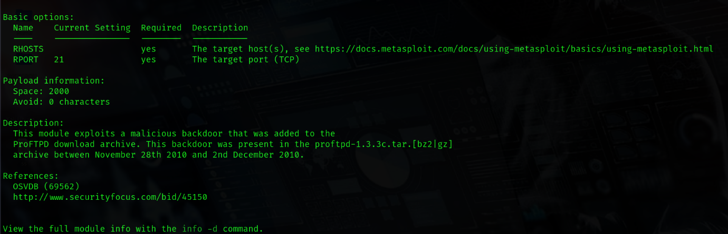

1. *find the BASIC OPTIONS in the info which appeared and set the RHOSTS, RPORT, LHOST, LPORT*
2. ***set RHOSTS TargetIP*** - Rhost is the target host so we give the target Ip here
3. ***set RPORT TargetPort*** - In Rport we give the remote port in which we want to attack

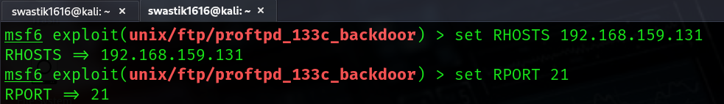

1. ***set LHOST YourIP*** - Lhost means the listening host which should be us, because Metasploit framework doesn’t know that where to send back the shell, that’s why we need to specify our Ip here.
2. ***set LPORT anything(like 1234)*** - The listening port can be anything because it doesn’t matter.

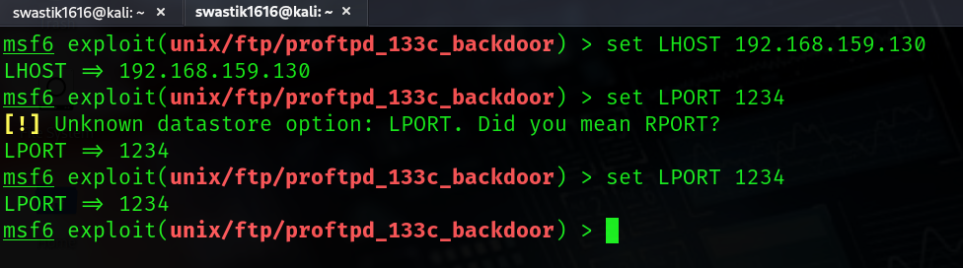

1. ***show options*** - to see all the options which we have set

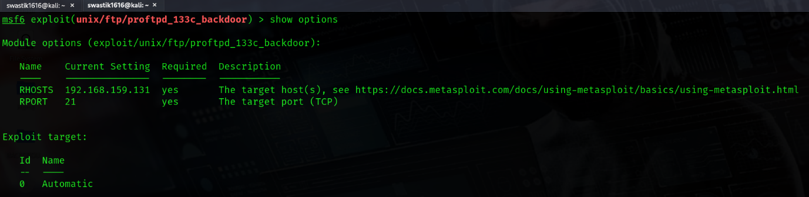

1. ***show payload*** - it lists all the compatible payloads which are working with the corresponding exploit.

It is recommended to use payloads which have a word called ***meterpreter*** in the, and if it is not available then use the payload having the word ***reverse*** in them, and at last when both are unavailable then use any generic payloads

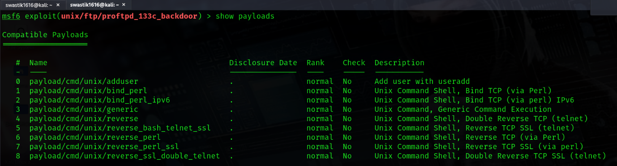

1. ***set payload PayloadPath*** - to set the payload to the one you selected

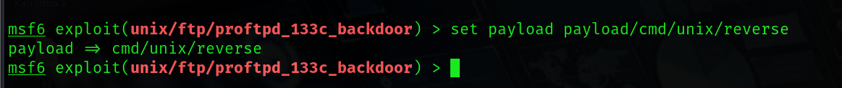

1. **exploit or run** *-*  final command after setting everything to exploit the vulnerability and access the target, after running this command we will have the full access of the target as its root.

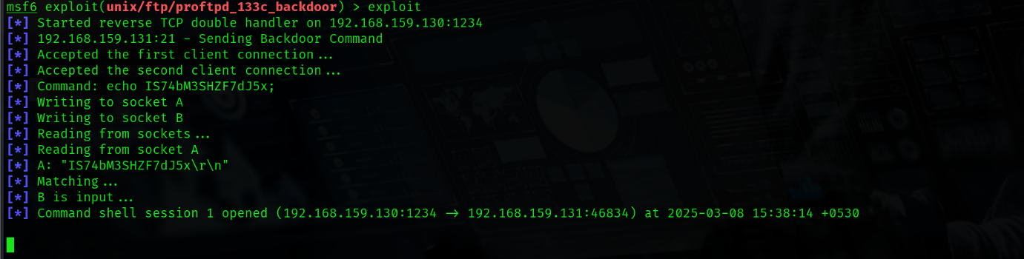

1. Now after entering the shell of the target we can do anything we want, also we can use the command ***background***  to get back to metasploit while being in the session and not terminating it, and we can use the command ***sessions***  in metasploit to confirm that we are still connected to the target, don’t use the command ***exit*** because it will terminate that session.

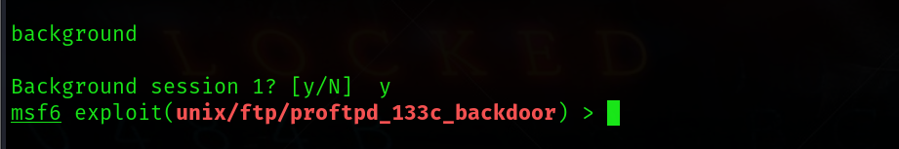

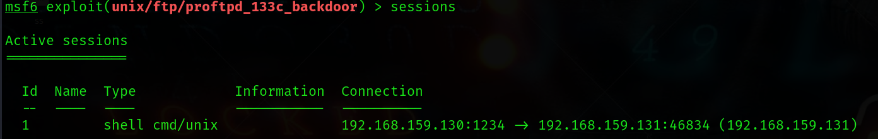

1. ***sessions -u SessionId or SessionName*** - to upgrade the session and get access of the stronger payloads like meterpreter.

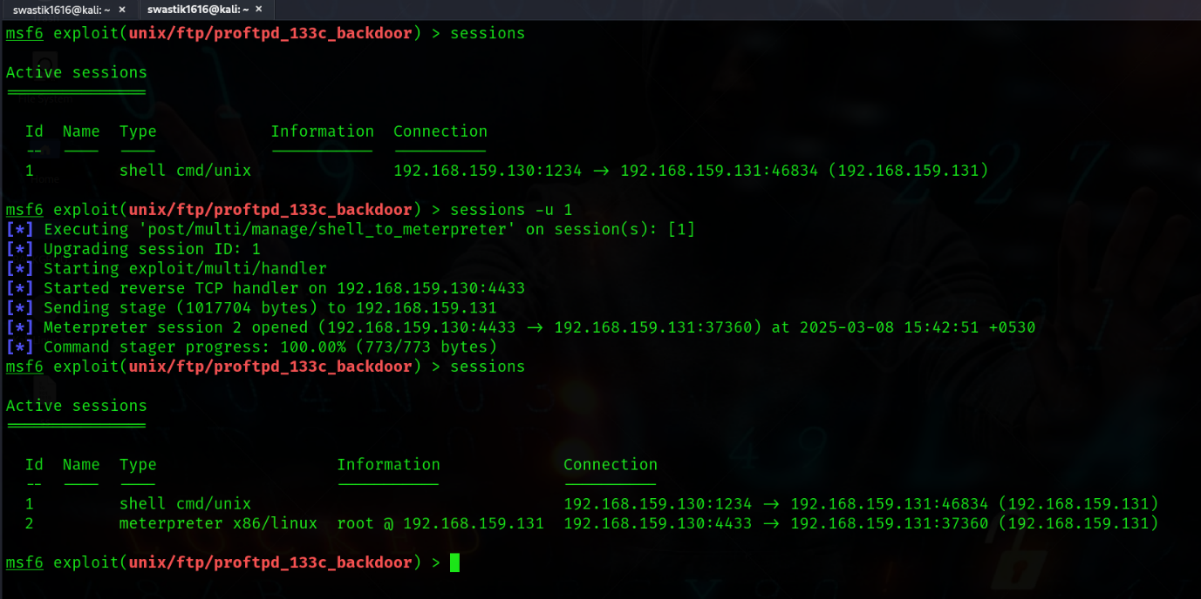

1. ***sessions SessionId or SessionName*** - to interact with the corresponding session

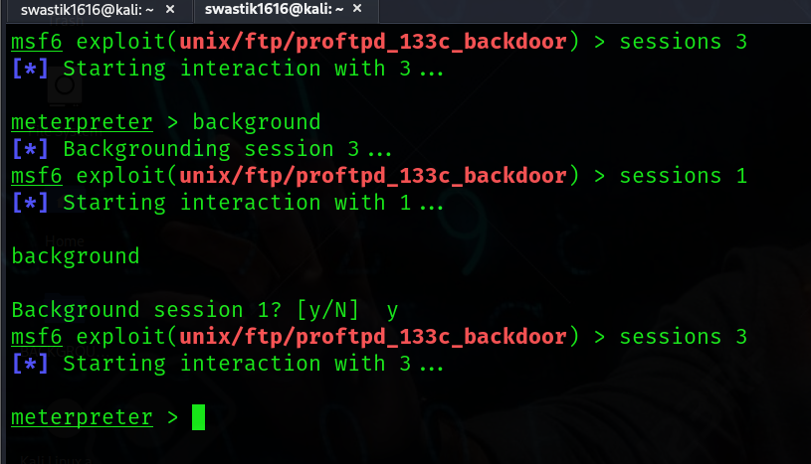

1. ***help*** - command to see what all we can do in the target
2. ***shell*** - If we don’t get the desired options, then we can run this command in the meterpreter to use the shell of the target and then use the command ***exit*** to get out of the shell and come back to meterpreter.

***TARGET'S DESKTOP BEFORE***

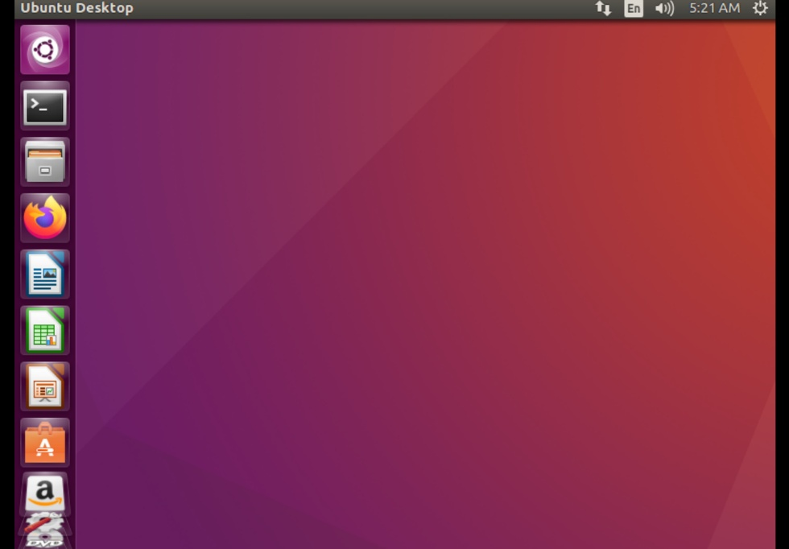

***ME RUNNING COMMANDS FROM MY SYSTEM***

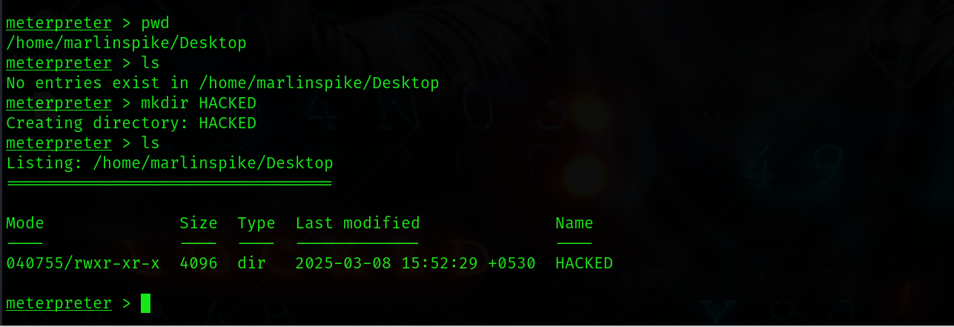

***TARGET'S DESKTOP NOW***

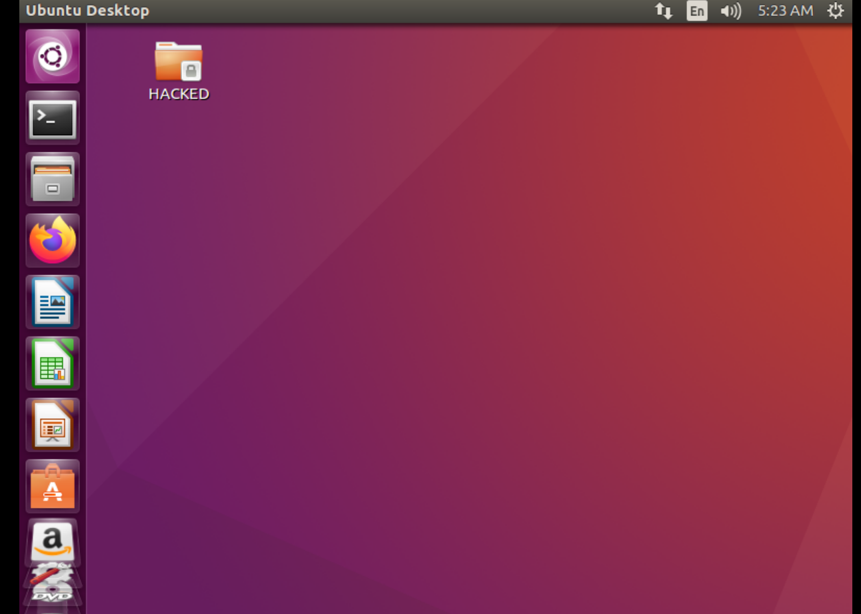

***SUCCESSFULLY HACKED MY FIRST VIRTUAL LAB USING METASPLOIT FRAMEWORK***

***RADHE RADHE***